19th – 29th July, 2018

Bratislava, SLOVAKIA

Prague, CZECH REPUBLIC

www.50icho.eu

**PREPARATORY PROBLEMS: THEORETICAL**

|  |  |
| --- | --- |
|  | **50th IChO 2018**  International Chemistry Olympiad  SLOVAKIA & CZECH REPUBLIC  BACK TO WHERE IT ALL BEGAN |

Table of Contents

Preface 2

Contributing Authors 3

Fields of Advanced Difficulty 4

Physical Constants, Formulae and Equations 5

Periodic Table of Elements 7

Visible Light Spectrum 8

Problem 1. Synthesis of hydrogen cyanide 9

Problem 2. Thermochemistry of rocket fuels 10

Problem 3. HIV protease 12

Problem 4. Enantioselective hydrogenation 14

Problem 5. Ultrafast reactions 15

Problem 6. Kinetic isotope effects 17

Problem 7. Designing a photoelectrochemical cell 19

Problem 8. Fuel cells 22

Problem 9. Acid-base equilibria in blood 24

Problem 10: Ion exchange capacity of a cation exchange resin 25

Problem 11. Weak and strong cation exchange resin 26

Problem 12: Uranyl extraction 27

Problem 13. Determination of active chlorine in commercial products 29

Problem 14. Chemical elements in fireworks 30

Problem 15. Colours of complexes 31

Problem 16. Iron chemistry 33

Problem 17. Cyanido- and fluorido-complexes of manganese 37

Problem 18. The fox and the stork 39

Problem 19. Structures in the solid state 42

Problem 20. Cyclobutanes 44

Problem 21. Fluorinated radiotracers 45

Problem 22. Where is lithium? 47

Problem 23. Synthesis of eremophilone 48

Problem 24. Cinnamon all around 50

Problem 25. All roads lead to caprolactam 53

Problem 26. Ring opening polymerization (ROP) 54

Problem 27. Zoniporide 56

Problem 28. Nucleic acids 60

Preface

We are happy to introduce the Preparatory Problems for the 50th International Chemistry Olympiad. These problems are intended to make the preparation for the Olympiad easier for both students and their mentors. The problems we prepared cover a wide range of challenging topics in modern chemistry. We based the problems on subjects typically covered in high school chemistry courses as well as six topics of advanced difficulty for the Theoretical part and two topics of advanced difficulty for the Practical part. These topics are listed under “Topics of Advanced Difficulty”, and their applications are shown in the preparatory problems. Based on our experience, each of these topics can be introduced to well-prepared students in two to three hours.

The solutions will be sent to the head mentor of each country by email by 15th February 2018 and will be published online on 1st June 2018. We welcome any comments, corrections and questions about the problems via email at info@50icho.eu.

We wish you a lot of fun solving the problems and we look forward to seeing you in July in Bratislava and Prague.

**Acknowledgment**

We would like to thank all the authors for their hard and dedicated work on both the preparatory and competition problems. We are also grateful to the reviewers for their valuable comments and suggestions.

Bratislava and Prague, 30th January 2018

On behalf of the Scientific Committee,

Petra Ménová and Martin Putala

Contributing Authors

Ctirad Červinka University of Chemistry and Technology, Prague

Tomáš Fiala Columbia University, New York, USA

Ivana Gergelitsová University of Chemistry and Technology, Prague

Petr Holzhauser University of Chemistry and Technology, Prague

Jakub Hraníček Charles University, Prague

Martin Hrubý Institute of Macromolecular Chemistry, CAS, Prague

Vít Jakeš University of Chemistry and Technology, Prague

Jan Kotek Charles University, Prague

Michal H. Kolář Max Planck Institute for Biophysical Chemistry, Göttingen, Germany

Matouš Krömer Institute of Organic Chemistry and Biochemistry, CAS, Prague

Tomáš Kubař Karlsruhe Institute of Technology, Germany

Jaroslav Kvíčala University of Chemistry and Technology, Prague

Alan Liška J. Heyrovský Institute of Physical Chemistry, CAS, Prague

Tomáš Mahnel University of Chemistry and Technology, Prague

Radek Matuška Secondary Technical School of Chemistry, Brno

Petra Ménová University of Chemistry and Technology, Prague

Lukáš Mikulů University of Chemistry and Technology, Prague

Petr Motloch University of Cambridge, UK

Eva Muchová University of Chemistry and Technology, Prague

Roman Nebel J. Heyrovský Institute of Physical Chemistry, CAS, Prague

Tomáš Neveselý University of Chemistry and Technology, Prague

Pavla Perlíková Institute of Organic Chemistry and Biochemistry, CAS, Prague

Eva Pluhařová J. Heyrovský Institute of Physical Chemistry, CAS, Prague

Kateřina Rubešová University of Chemistry and Technology, Prague

Pavel Řezanka University of Chemistry and Technology, Prague

Petr Slavíček University of Chemistry and Technology, Prague

Ondřej Šimůnek University of Chemistry and Technology, Prague

Tomáš Tobrman University of Chemistry and Technology, Prague

Kamil Záruba University of Chemistry and Technology, Prague

Edited by

Petra Ménová University of Chemistry and Technology, Prague

Martin Putala Comenius University in Bratislava

Fields of Advanced Difficulty

1. *Thermodynamics*: relation of equilibrium constants and standard Gibbs energy, van 't Hoff equation, weak acid-base equilibria
2. *Kinetics*: integrated rate law for first- and second-order reactions, half-life, Arrhenius equation, relaxation methods in chemical kinetics, kinetic isotope effects
3. *Electrochemistry*: electrochemical cells, Nernst-Peterson equation, Latimer, Frost and Pourbaix diagrams
4. *Inorganic complexes*: crystal field theory
5. *Stereochemistry*: organic stereochemistry, diastereoselective reactions
6. *DNA and RNA*: nucleobases, hydrogen bonding between bases and its thermodynamics

*Notes*

We do not expect students to get an advanced training in the following topics met in the preparatory problems as they WILL NOT appear in the exam set.

* Claisen rearrangement
* Chemistry of *N*-oxides
* Arrow-pushing mechanisms
* Use of spreadsheet software
* Solving cubic equations

Polymer chemistry will be covered only from the viewpoint of organic chemistry.

No further biochemistry of nucleic acids than covered in the preparatory problems.

Unless stated otherwise, the number of significant figures reported by the student will not be evaluated.

Physical Constants, Formulae and Equations

Avogadro's constant: *N*A = 6.022 × 1023 mol−1

Universal gas constant: *R =* 8.314 J K−1 mol−1

Speed of light: *c =* 2.998 × 108 m s−1

Planck's constant: *h =* 6.626 × 10−34 J s

Faraday constant: *F* = 9.6485 × 104 C

Standard pressure: *p* = 1 bar = 105 Pa

Standard atmospheric pressure: *p*atm = 1.01325 × 105 Pa

Zero of the Celsius scale: 273.15 K

Mass of electron: *me* = 9.109 × 10−31 kg

1 Å = 10−10 m

1 eV = 1.602 × 10−19 J

1 amu = 1.6605 × 10−27 kg

Ideal gas equation: $pV=nRT$

The first law of thermodynamics: $∆U=q+W$

Power input for electrical device: $P=UI$, where $U$ is voltage and $I$ electric current

Enthalpy: $H=U+pV$

Gibbs free energy: $G=H-TS$

$$ΔG=ΔG^{o}+RTlnQ$$

Reaction quotient $Q$ for a reaction *aA* + *bB* ⇌ *cC* + *dD $Q=\frac{{\left[C\right]}^{c}{\left[D\right]}^{d}}{{\left[A\right]}^{a}{\left[B\right]}^{b}}$*

$$ΔG^{o}=-RTlnK=-zFE_{cell}^{o}$$

Entropy change: $ΔS=\frac{q_{rev}}{T}$, where $q_{rev}$ is heat for the reversible process

Heat change for temperature-independent molar heat capacity ($c_{m}$): $Δq=nc_{m}ΔT$

Van ’t Hoff equation: $\frac{dlnK}{dT}=\frac{Δ_{r}H_{m}}{RT^{2}}⇒ln\left(\frac{K_{2}}{K_{1}}\right)=-\frac{Δ_{r}H_{m}}{R}\left(\frac{1}{T_{2}}-\frac{1}{T_{1}}\right)$

Henderson–Hasselbalch equation: $pH= pK_{a}+log\frac{\left[A^{-}\right]}{\left[HA\right]}$

Nernst–Peterson equation: $E=E°+\frac{RT}{zF}ln\frac{c_{ox}}{c_{red}}$

Energy of a photon: $E=\frac{hc}{λ}$

Relation between energy in eV and in J: $E [eV]=\frac{E [J]}{q_{e}}$

Lambert–Beer law: $A=log\frac{I_{0}}{I}=εbC$

Wavenumber: $\tilde{ν}=\frac{ν}{c}=\frac{1}{2πc}\sqrt{\frac{k}{μ}}$

Reduced mass *µ*, for a molecule AX: $μ=\frac{m_{A}⋅m_{X}}{m_{A}+m_{X}}$

Integrated rate laws:

Zero order: $[A]=[A]_{0}-kt$

First order: $ln[A]=ln[A]_{0}-kt$

Second order: $\frac{1}{[A]}=\frac{1}{[A]_{0}}+kt$

Arrhenius equation: $k=Ae^{-E_{a}/RT}$

Periodic Table of Elements

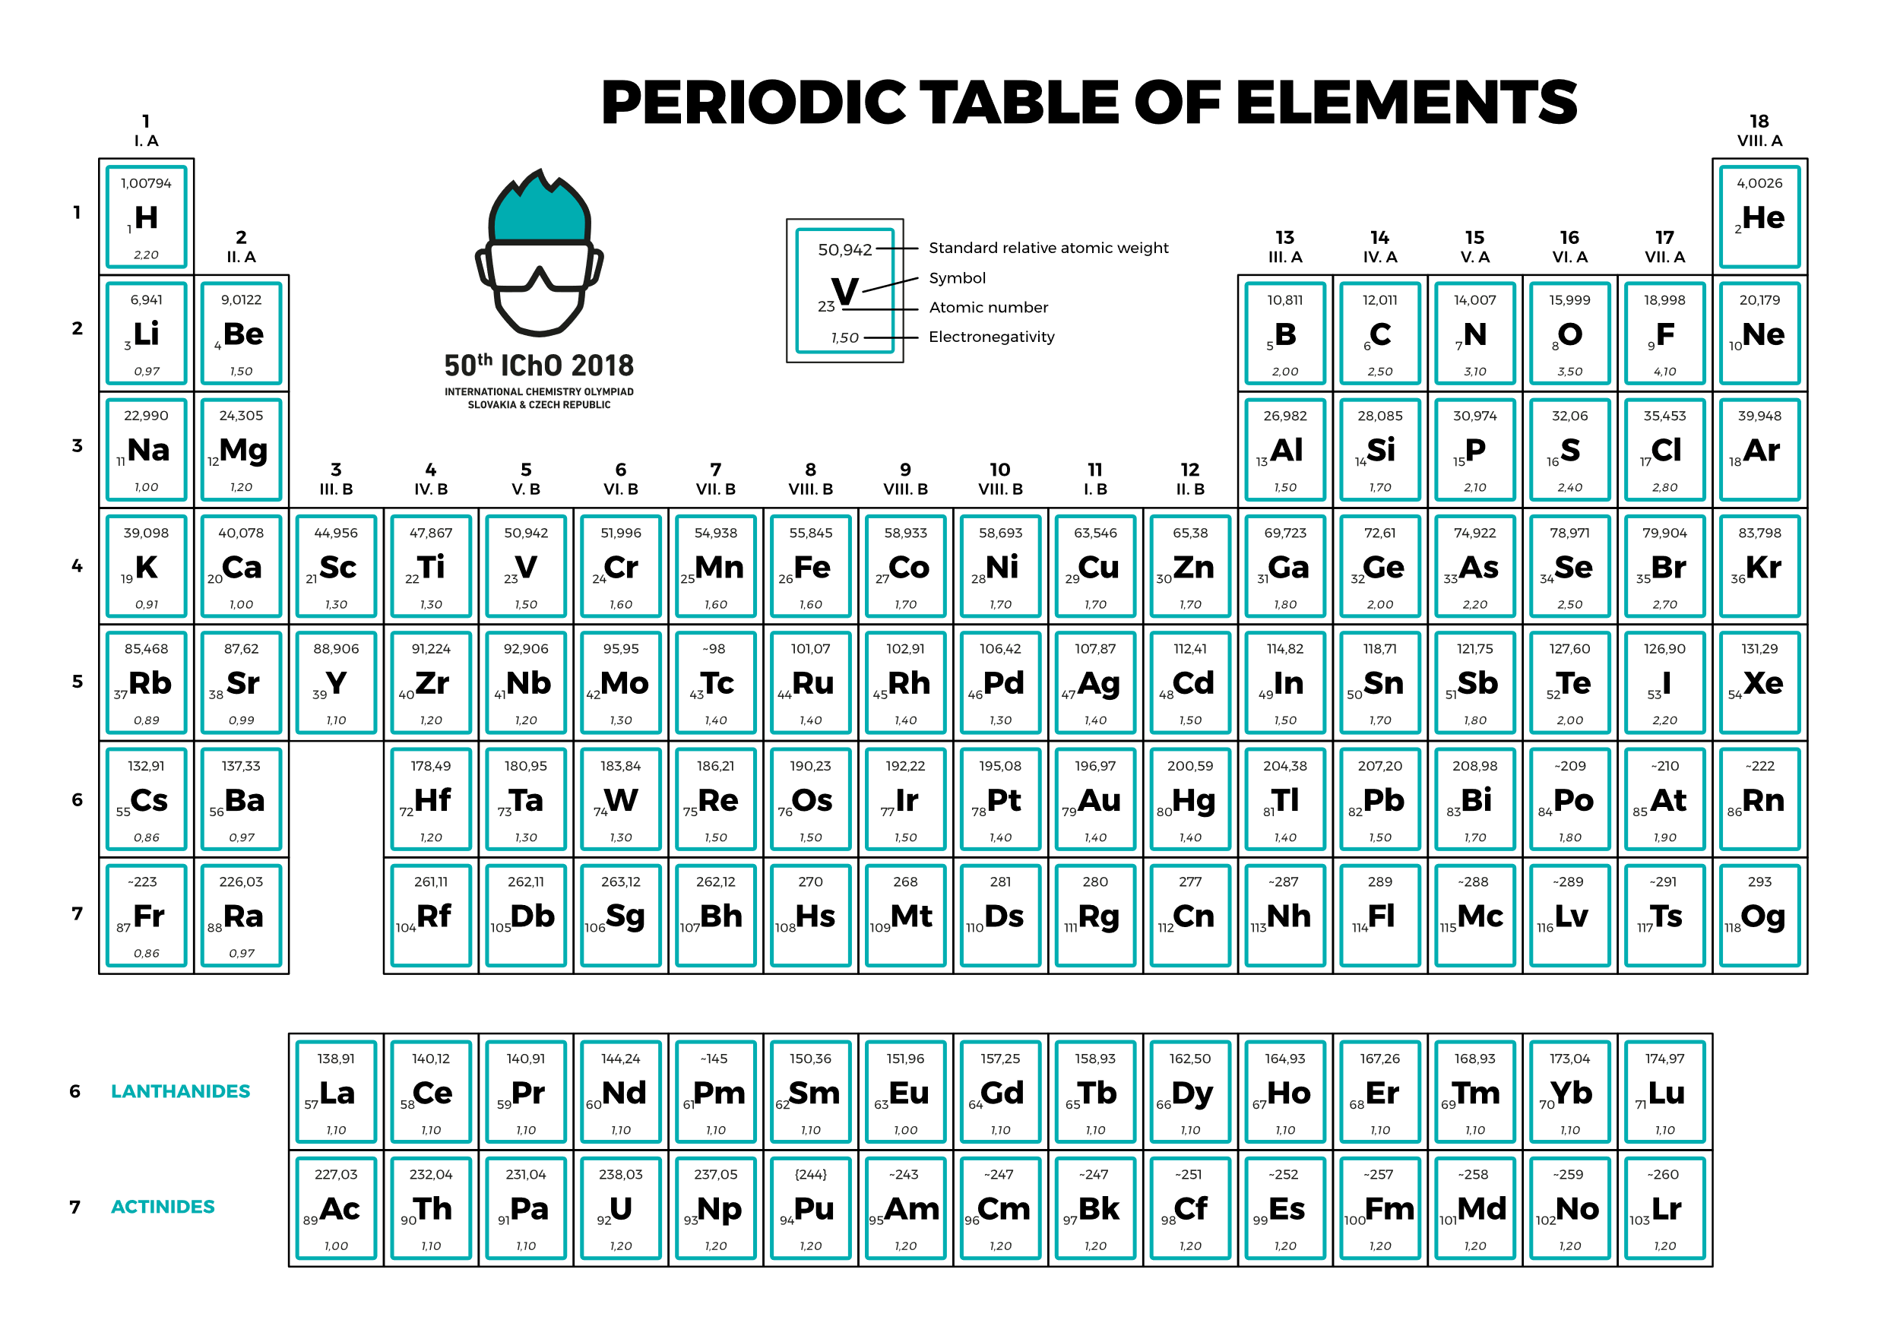

Visible Light Spectrum

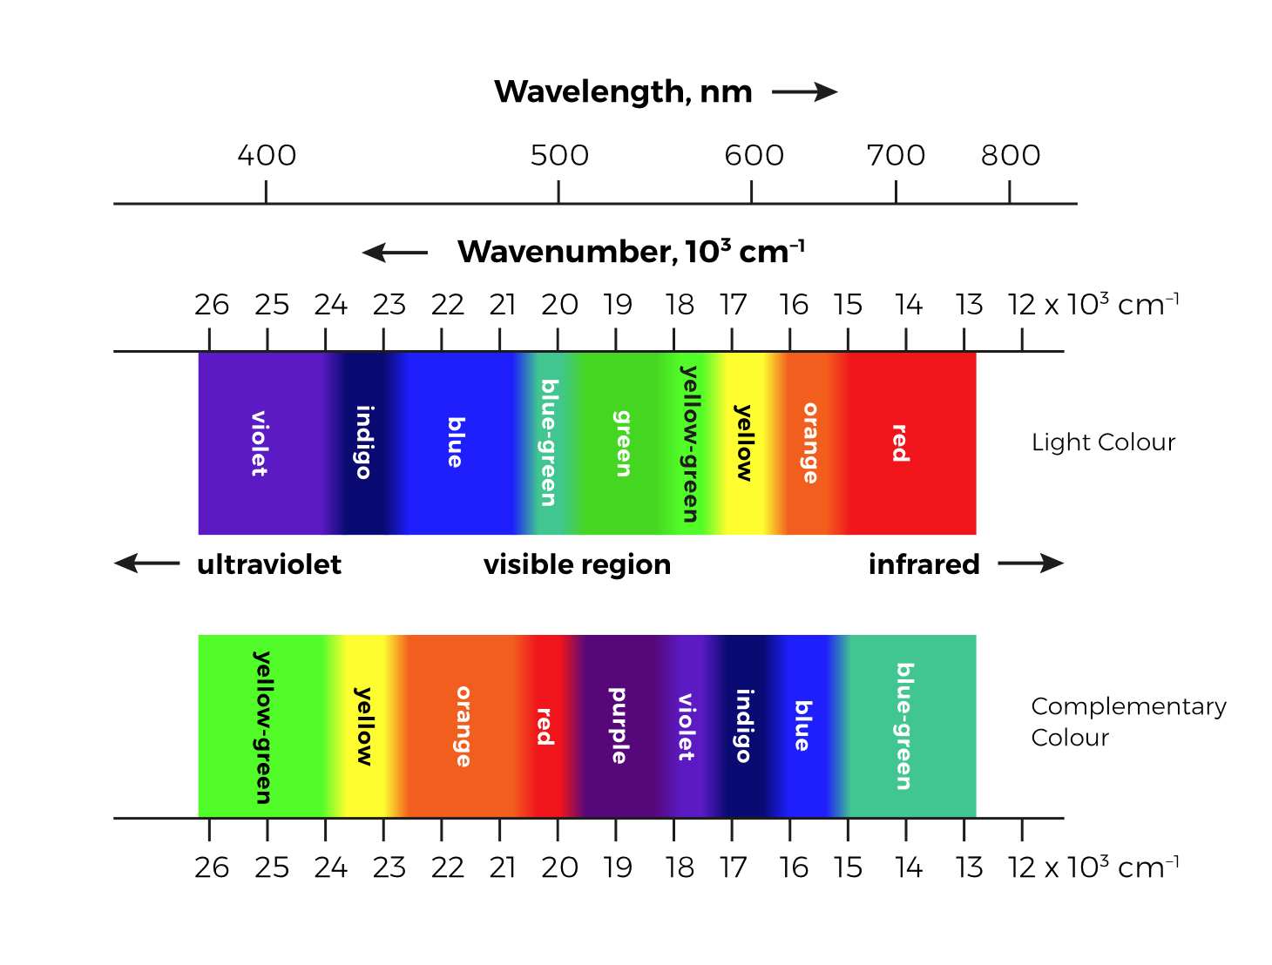

Problem 1. Synthesis of hydrogen cyanide

Hydrogen cyanide (HCN) is a colourless liquid with a characteristic almond-like odour. It can be produced when sufficient energy is supplied to numerous systems containing hydrogen, nitrogen, and carbon. Today, only the processes starting from hydrocarbons and ammonia are of economic importance. Two main HCN production processes are:

* Degussa (BMA) process: CH4(g) + NH3(g) → HCN(g) + 3 H2(g)
* Andrussow process: CH4(g) + NH3(g) + 3/2 O2(g) → HCN(g) + 3 H2O(g)

Both processes take place at temperatures above 1 000 °C and at near standard pressure. Both of them require the use of special platinum catalysts.

1.1 Calculate a change in enthalpy Δr*H*m at 1 500 K for the reactions which take place in the Degussa process (BMA process) and in the Andrussow process, respectively. Use the data on the enthalpy of formation Δf*H*m given in the table below.

|  |  |
| --- | --- |
| **Compound** | **Δf*H*m(1** **500 K), kJ mol**−**1** |
| CH4(g) | −90.3 |
| NH3(g) | −56.3 |
| HCN(g) | 129.0 |
| H2O(g) | −250.1 |
| H2(g) | 0 |
| O2(g) | 0 |

1.2 Which process (Degussa BMA or Andrussow) requires the use of an external heater to keep the reaction system at 1 500 K? Why?

1.3 Calculate the equilibrium constant *K* of the reaction which takes place in the Degussa process (BMA process) at the temperatures of 1 500 K and 1 600 K. The standard change in Gibbs free energy for this reaction at 1 500 K is Δr*G*m(1 500 K) = −112.3 kJ mol−1. Assume that the reaction enthalpy at 1 500 K is constant over a temperature range from 1 500 K to 1 600 K. Is the result in accordance with Le Chatelier’s principle?

1.4 Referring to the Le Chatelier’s principle, estimate whether the equilibrium constant *K* of the reaction in the Andrussow process increases or decreases when the temperature changes from 1 500 K to 1 600 K.

Problem 2. Thermochemistry of rocket fuels

Common rocket engines that power spacecraft used for the transportation of space probes to Earth’s orbit or to leave its gravitational field rely on simple nitrogen-based fuels. Methylhydrazine and 1,1-dimethylhydrazine (also known as unsymmetrical dimethylhydrazine) are commonly used in combination with nitrogen dioxide (or fuming nitric acid) for this purpose. Despite the relatively high toxicity of the given hydrazine derivatives, these compounds possess several beneficial characteristics which make them most suitable for powering rocket engines in the outer space. First, all hydrazine derivatives form hypergolic (spontaneously ignitable) mixtures with nitrogen dioxide, making it possible for the engine to work without any additional ignition system. Next, the melting temperatures of both methylhydrazine and 1,1-dimethylhydrazine are sufficiently low, so these species remain liquid even at extreme conditions.

To investigate the thermochemical properties of selected derivatives of hydrazine, the following calorimetric experiments were performed. Samples of liquid hydrazine, methylhydrazine, and   
1,1-dimethylhydrazine, each weighing 1 gram, were combusted in an adiabatic bomb calorimeter operating at a constant volume, in a stoichiometric amount of oxygen. The temperature in the calorimeter was initially 298.15 K, and it increased by 8.25 K, 12.55 K and 14.76 K during the experiments with the respective individual compounds. By calibration, the heat capacity of the calorimeter was determined to be 2.04 kJ K−1.

2.1 Assuming that all three hydrazine derivatives react with oxygen to yield molecular nitrogen, water vapour and, if relevant, carbon dioxide at 298.15 K and 101 325 Pa, calculate the enthalpies of combustion for the reactants at the given conditions. Consider all gaseous species participating in the reaction to behave as ideal gas, and neglect any differences between the enthalpy and internal energy of all condensed phases.

2.2 Calculate the reaction enthalpies for combustion reactions of the three selected fuels with dinitrogen tetroxide at 298.15 K and 101 325 Pa (again, water vapour is produced). Consider all of the reacting hydrazine species to be liquid, mimicking the chemical processes occurring in rocket engines. Dinitrogen tetroxide enters the reaction in gaseous state. Use the standard enthalpies of formation of gaseous water (−241.83 kJ mol−1), carbon dioxide (−393.52 kJ mol−1) and dinitrogen tetroxide (9.08 kJ mol−1).

Extensive calorimetric experiments were performed for the relevant low-temperature phases of all chemical compounds present in the given systems at temperatures ranging from the vicinity of absolute zero up to ambient temperature. From these measurements, the absolute values of the standard molar entropies (at 298.15 K and 101 325 Pa) were evaluated according to the third law of thermodynamics:

|  |  |  |  |
| --- | --- | --- | --- |
| **Compound** | ***S°*, J K−1 mol−1** | **Compound** | ***S°*, J K−1 mol−1** |
| N2H4 (l) | 121.92 | N2 (g) | 191.61 |
| CH3N2H3 (l) | 166.35 | CO2 (g) | 213.79 |
| (CH3)2N2H2 (l) | 199.60 | H2O (l) | 69.95 |
| N2O4 (g) | 209.46 |  |  |

2.3 Calculate standard reaction Gibbs energies for the three combustion reactions with dinitrogen tetroxide, estimate the corresponding equilibrium constants and predict qualitatively the extent of reactions occurring at 101 325 Pa and 298.15 K. Assume that the reactions start from stoichiometric amounts of reactants, and water is produced in its standard state – liquid. Use the given standard entropy values and the molar vaporization enthalpy of water at 298.15 K, which amounts to 40.65 kJ mol−1.

2.4 In which direction do the total pressure and temperature affect the given chemical equilibria? In other words, does an increase in pressure or in temperature lead to an increase or a decrease in the extent of the reaction?

2.5 Within the adiabatic approximation, calculate the flame temperature for a 1:1:1 molar mixture of the three fuels reacting with 3.75 moles of N2O4 for the case when the reactants enter a combustion chamber at 298.15 K in the liquid state. The flame temperature can be calculated, assuming that the combustion reaction formally occurs at 298.15 K and all of the heat released by the reaction (enthalpy) is then consumed to warm up the gaseous products (including water vapour) to the resulting temperature of the flame. Approximate the isobaric heat capacities of the relevant compounds with the following constants.

|  |  |
| --- | --- |
| **Compound** | ***Cp*, J K−1 mol−1** |
| N2 (g) | 35.26 |
| CO2 (g) | 59.83 |
| H2O (g) | 52.29 |

2.6 Compare the calculated flame temperature obtained above for the mixture of fuels, using an analogous value corresponding to burning pure liquid 1,1-dimethylhydrazine in an oxygen atmosphere.

2.7 The critical temperature of oxygen is 154.6 K and the melting temperature of   
1,1-dimethylhydrazine is 216.0 K. Is there a temperature range in which the same   
liquid–fuel engine could be used for this alternative fuel setup?

2.8 Explain the extraordinarily high thermodynamic efficiency of rocket engines when compared to the other representatives of thermal engines (e.g. steam or Diesel engine) and support your answer with a quantitative argument.

Problem 3. HIV protease

Human immunodeficiency virus (HIV) is a retrovirus that causes acquired immunodeficiency syndrome (AIDS). AIDS is a condition in which the afflicted patient’s immune system fails progressively, allowing otherwise benign infections to be life-threatening. The life cycle of HIV relies on the enzyme HIV-1 protease. As this enzyme plays a crucial role in the replication of the virus, HIV-1 protease has been a prominent target for therapy, with drugs being designed to inhibit the action of the enzyme. An HIV-1 protease inhibitor binds to the active site of the enzyme more strongly than the substrate that it mimics, thus disabling the enzyme. Consequently, without active HIV-1 protease present, viral particles do not mature into infectious virions.

Several inhibitors of HIV-1 protease have been licensed as drugs for HIV therapy. A detailed thermodynamic and kinetic study of seven then-available inhibitors of HIV-1 protease was performed in 2003 in Uppsala (interested readers are referred to the original publication in *J. Mol. Recognit.* DOI: 10.1002/jmr.655). The molecular structures of six of them are shown below.

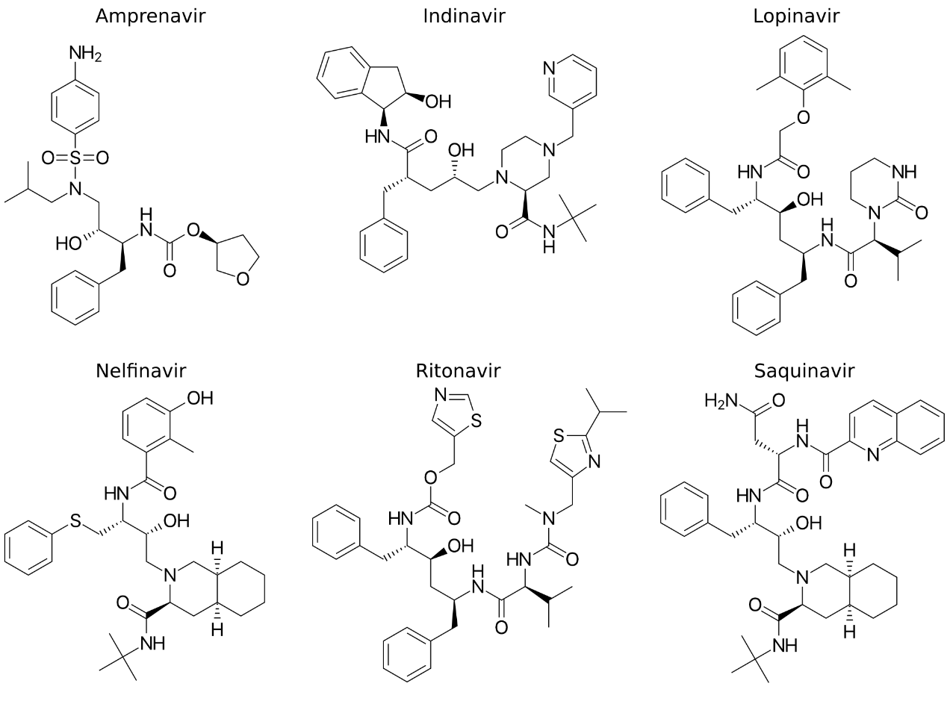

The affinity of the selected compounds to the HIV-1 protease was measured in terms of equilibrium constants for the dissociation of the protease–inhibitor complex, in a range of temperatures from 5 °C to 35 °C under otherwise identical conditions including pH. The obtained data are presented below; dissociation constants *K*D are in units of nM, i.e. 10−9 mol dm−3.

|  |  |  |  |  |  |  |
| --- | --- | --- | --- | --- | --- | --- |
| **Temperature °C** | **Amprenavir** | **Indinavir** | **Lopinavir** | **Nelfinavir** | **Ritonavir** | **Saquinavir** |
| 5 | 1.39 | 3.99 | 0.145 | 6.83 | 2.57 | 0.391 |
| 15 | 1.18 | 2.28 | 0.113 | 5.99 | 1.24 | 0.320 |
| 25 | 0.725 | 1.68 | 0.101 | 3.67 | 0.831 | 0.297 |
| 35 | 0.759 | 1.60 | 0.0842 | 2.83 | 0.720 | 0.245 |

3.1 Which of the compounds binds most strongly to the protein at 35 °C?

3.2 Calculate the standard Gibbs energy of binding (i.e. association) for each compound at each temperature. It may be of advantage to use a spreadsheet application.

3.3 Use the temperature-dependent data to calculate the standard enthalpy and entropy of binding of each of the compounds. Consider the enthalpies and entropies to be independent of temperature in the interval 5–35 °C.

The dissociation rate constants *k*D (in the units of 10−3 s−1) of the protease–inhibitor complexes for each inhibitor at two temperatures are presented below:

|  |  |  |  |  |  |  |
| --- | --- | --- | --- | --- | --- | --- |
| **Temperature °C** | **Amprenavir** | **Indinavir** | **Lopinavir** | **Nelfinavir** | **Ritonavir** | **Saquinavir** |
| 5 | 1.85 | 1.88 | 0.506 | 0.912 | 1.93 | 0.146 |
| 25 | 4.76 | 3.44 | 0.654 | 2.17 | 2.59 | 0.425 |

3.4 Identify the inhibitor with the slowest dissociation from the protease at 25 °C.

3.5 Calculate the rate constants of association (i.e. binding) of the protein–inhibitor complexes, *k*A, at 25 °C for all inhibitors. Which of the inhibitors exhibits the fastest association with the protease?

3.6 Using the Arrhenius equation, calculate the activation free energy of dissociation Δ*G*‡   
(or *E*a) of Lopinavir as well as that of the slowest dissociating inhibitor from question 3.4, and the compound with the largest association rate constant (which were obtained in question 3.5). Assume that the activation free energy is constant in the respective temperature range.

3.7 Is the inhibitor with the largest activation energy for dissociation the same compound as the strongest binder which was identified in question 3.1? We may extrapolate this finding: What relationship is there between the strength of binding expressed by the dissociation constant and the rate of dissociation expressed by the activation energy of dissociation?

Problem 4. Enantioselective hydrogenation

The hydrogenation of acetophenone with chiral catalyst **(*R*)-CAT** (2 mol%) at −40 °C for 8 hours gives a crystalline solid, (*R*)-1-phenylethan-1-ol, in 70% yield and 90% enantiomeric excess (*ee*). The specific rotation [*α*]D20 (*c* 1.00, EtOH) of the product was determined to be +45°.

4.1 Draw the structure of the product.

4.2 The rate constant of the reaction leading to the (*R*)-product is *kR*= 2.5 × 10−5s−1 at −40 °C. What is the rate constant *kS* of the reaction that leads to the the (*S*)-product at the same temperature?

4.3 The activation energy for the reaction leading to the (*S*)-product is *Ea*(*S*) = 80 kJ mol−1. Provided that the pre-exponential factor *A* is the same for both reactions, what is the activation energy *Ea*(*R*) for the reaction leading to the (*R*)-product?

4.4 What temperature is needed to obtain 99% *ee*?What is a potential drawback?

4.5 Determine the specific rotation [*α*]D20 (*c* 1.00, EtOH) of the product if **(*S*)-CAT** (4 mol%), an optical antipode to the catalyst **(*R*)-CAT**, is used at 0 °C and the same machine and cuvette are used for the measurement.

4.6 How would you increase the optical purity of the final product after the reaction?

Problem 5. Ultrafast reactions

*The rate of true neutralization reactions has proved to be immeasurably fast.*

Eucken’s Lehrbuch der Chemischen Physik, 1949

The main problem with studying ultrafast reactions is mixing the reactants. A smart way to circumvent this problem is the so-called relaxation technique.

Neutralization is a good example of an ultrafast reaction:



Here, *k1* and *k2* are the rate constants for the forward and backward reaction, respectively. The mean enthalpy for this reaction is −49.65 kJ mol−1 in the temperature range 298–373 K. The density of water is 1.000 g cm−3.

5.1 Water has pH = 7.00 at 298 K. Calculate the apparent equilibrium constant $K=\frac{\left[H_{2}O\right]}{\left[H^{+}\right]\left[{OH}^{-}\right]}$ of the neutralization reaction shown above. Calculate also the entropy change for the reaction.

5.2 Estimate the pH of boiling water (*T* = 373 K).

Heavy water undergoes an analogous neutralization reaction, yet it is less dissociated than light water at the given temperature: *K*w(D2O) = 1.35 × 10−15 at 298 K.



5.3 What is pD of heavy water at 298 K?

5.4 Write the rate law for the change of the concentration of D2O in terms of the concentrations of D+, OD− and D2O.

The composition of the equilibrium system depends on temperature. If we apply an external stimulus, for example a very fast heat pulse on the system, we disturb the equilibrium and observe a subsequent relaxation to the equilibrium composition. We can describe the relaxation with   
a new quantity *x*, a deviation from the equilibrium concentrations:

$$x= {\left[D_{2}O\right]}_{eq}-\left[D_{2}O\right]=\left[{OD}^{-}\right]-{\left[{OD}^{-}\right]}_{eq}=\left[D^{+}\right]-{\left[D^{+}\right]}_{eq}$$

5.5 Express the time change $\frac{dx}{dt}$ in terms of *x*. Give both the exact equation and the equation in which you neglect the small terms of *x*2.

Solving the equation derived in 5.5, we get:

$$x=x\left(0\right)×exp⁡(-t×{(k}_{1}{\left[D^{+}\right]}_{eq}+k_{1}{\left[{OD}^{-}\right]}_{eq}+k_{2}))$$

where $x\left(0\right)$ is the deviation from equilibrium at the moment of perturbation.

5.6 For heavy water at 298 K, the relaxation time $τ$ (time at which the deviation from equilibrium drops to $\frac{1}{e}$ of the initial value) was measured to be 162 µs. Calculate the rate constant for the forward and backward reaction. The density of heavy water is *ρ* = 1.107 g cm−3 and molar mass is *M*r = 20.03.

Ultrafast reactions can also be triggered by a pH jump. Using an ultrafast laser pulse, we can induce a pH jump in a system with so-called photoacids. These compounds have dramatically different acid-base properties in the ground and excited electronic states. For example, the p*K*a of 6-hydroxynaphthalene-2-sulfonate is 9.12 in the ground state and 1.66 in the excited state.



5.7 1 cm3 of 5.0 × 10−3 mol dm−3 6-hydroxynaphthalene-2-sulfonate solution was irradiated by light with the wavelength of 297 nm. The total absorbed energy was 2.228 × 10−3 J. Calculate the pH before and after irradiation. Neglect the autoprotolysis of water in both cases.

*Note* that the standard state for a solution is defined as *c*0 = 1 mol dm−3 and assume that the activity coefficient is *γ*i = 1 for all species. It may be of advantage to use an online cubic equation solver.

Problem 6. Kinetic isotope effects

Various isotopes of a given atom obey the same chemical principles, but their different masses cause different behaviour in a dynamic sense. The kinetic isotope effect refers to a phenomenon wherein isotopically substituted molecules react at different rates. It was postulated in 1933 by Eyring and Polanyi and since then kinetic isotope effects have provided detailed information about mechanisms of many organic and biochemical reactions.

Vibrational modes are quantized and we can use the harmonic oscillator approximation for the description of the stretching modes. The energy level *E*v can be calculated as:

$$E_{v}= \left(v+\frac{1}{2}\right)hν ,$$

where v = 0, 1, 2, ... is the vibrational quantum number and $ν$ the frequency which depends on the force constant *k* and the reduced mass *µ*:

$$ν=\frac{1}{2π}\sqrt{\frac{k}{μ}} .$$

*Note for the following calculations*: unless stated otherwise, round the isotopic mass in amu to the nearest integer.

6.1 Let us start with a simple diatomic molecule 1HF. Calculate its harmonic vibrational wavenumber in cm–1 and energies of the first two vibrational levels in J. The value of the harmonic force constant is *k* = 968 kg s−2.

6.2 Isotopic substitution does not change the potential energy surface of a molecule. Therefore, *k* remains unaffected. Given the vibrational wavenumbers of 1HAX (2 439.0 cm−1) and   
2DA+2X (1 734.8 cm−1), determine the unknown element X.

6.3 Zero-point vibrational energy is the key contributor to the kinetic isotope effect. If we assume that the bond is fully broken at the transition state and only the ground vibrational state is populated, the difference in activation energies has the same absolute value as the difference in zero-point vibrational energies. The wave numbers of the C−H and C−D stretches are 2 900 cm−1 and 2 100 cm−1, respectively. Calculate the ratio of the rate constants *k*(C−H)/*k*(C−D) for the cleavage of the C−H/D bond at 300 K, taking into account only the difference in zero-point vibrational energies.

6.4 Kinetic isotope effects provide insight into the rate-determining step of a reaction mechanism. The ratio of *k*H/*k*D for the formation of propene from 1-bromopropane and   
1-bromo-2,2-dideuteriopropane in basic solution is 6.5. Does the reaction proceed by E1 or E2 mechanism? E1 takes place in two steps: formation of the carbocation intermediate followed by loss of H+. E2 occurs in a single step involving removal of the halide at the same time as the neighbouring hydrogen.



6.5 Let us consider the formation of the corresponding alkene from 2-bromo-3,3-  
-dideuterio-2-methylbutane and its light-hydrogen analogue upon heating in ethanol. How significant would the kinetic isotope effect be in this case?

Problem 7. Designing a photoelectrochemical cell

One of the most challenging issues for future technologies is to maximize the energy gain from renewable sources: solar, wind, hydropower, geothermal and biomass. Although they represent clean and highly abundant sources of energy with a tremendous physical potential, they are intermittent, which applies mainly to solar energy. This means that they are not available when and where needed, or at least not all the time: the sun sets, wind does not blow, etc. One of the possible solutions to this problem is to store energy in a medium that is long-lasting and dispatchable. Chemical bonds represent such a medium. In general, this is the concept of solar fuels.

Such a system is already readily available in nature: photosynthesis. Plants use sunlight to make fuel (carbohydrates) out of water and carbon dioxide. To be able to do that, however, plants need fertile soil, water and favourable climate. On the other hand, artificial photosynthetic systems are not limited by such constraints and are capable of producing a fuel with a higher energy density, like hydrogen. Photoelectrochemical (PEC) water splitting is a powerful, yet complex process. By completing the upcoming tasks, you will get a basic insight into photoelectrochemistry.

7.1 Which of the following half-reactions have reduction potentials dependent on pH?



7.2 Using the Nernst-Peterson equation and considering [**A**ox] = [**A**red], derive a formula for the dependence of the reduction potential of the following reaction on pH:



What is the nature of this dependence (logarithmic, exponential, quadratic, etc.)?

7.3 Let us consider two possible reactions occurring in an electrolyte:



1. Which of the two possible reactions will occur under the conditions of *p* = 1 atm, *T*= 298.15 K? Will substance **B** oxidize **C** or will substance **C** oxidize **B**? Write a balanced chemical equation for the reaction between substances **B** and **C**.
2. Determine the standard potential for such a reaction.
3. Calculate the equilibrium constant for this reaction.

7.4 Now, let us consider the electrochemical system of two reactions that can occur in a cooled experimental cell, where one of them is pH-dependent and the other is not:



1. Calculate the change in potential (in millivolts) as a function of pH for the pH-dependent reaction. The given potentials correspond to pH = 0 and *T* = 262 K. The only parameter that can be changed during the experiment is the pH value of electrolyte.
2. Draw a straight line plot of the dependence of the reduction potentials (for both **D** and **E**) on pH in the range from 0 to 13.
3. Find the value of pH at which the equilibrium constant for the oxidation of substance **E** is *K* = 2.56 × 105.
4. Show on the drawn plot the region of pH where **D** will oxidize **E**.

7.5 Calculate the time needed to electrolytically cover a 5 × 10 × 0.5 mm metallic plate fully immersed into 10 cm3 of the solution of a gold precursor with *c*(Au3+) = 5 mmol dm−3 with 5 mg of a gold protective film. Consider that only gold (*M*Au = 197 g mol−1) is being deposited on the surface of the metallic plate, no side reactions occur, the surface area of the contacts with the electrode is negligible, and there is a constant current of 25 mA during the process.

Once the substrate for testing electrode is covered with a highly conducting and relatively   
non-reacting coating (e.g. gold), a photocatalyst can be added. Thanks to their chemical stability in aqueous environment, metal oxide-based semiconductors are suitable materials for  
photo-electrochemical applications. Recently, titanium dioxide has emerged as an excellent photocatalyst. It is an n-type semiconductor and can be used as a material for photoanodes. The whole complex mechanism of photoreactions occurring on irradiated n-type semiconductors can be simplified as follows. A photon with sufficient energy (wavelength) strikes the surface of a semiconductor and an electron from the highest occupied molecular orbital (HOMO) is excited to the lowest unoccupied molecular orbital (LUMO), leaving a positively charged hole (h+) behind. When applying an external electric field, the excited electrons are driven through the system to the counter-electrode where they participate in reduction reactions while photogenerated holes participate in oxidation reactions. The observed flow of electrons is called net photocurrent.

Let us call *E*g the difference between the energy levels of HOMO and LUMO. It denotes the minimum excitation energy (maximum wavelength) of irradiation. To choose the optimal photocatalyst for a redox reaction, two main presumptions exist: 1) the *E*g of a semiconductor has to be “accurately” wider than the potential of a redox reaction; 2) the energy level of HOMO has to be below the energy level of the oxidation half-reaction while the energy level of LUMO has to be above the energy level of the reduction half-reaction.

7.6 In the following picture you can see a schematic view of an energy diagram comparing four materials (**F**–**I**) by positions of their HOMOs and LUMOs towards the investigated redox reaction.

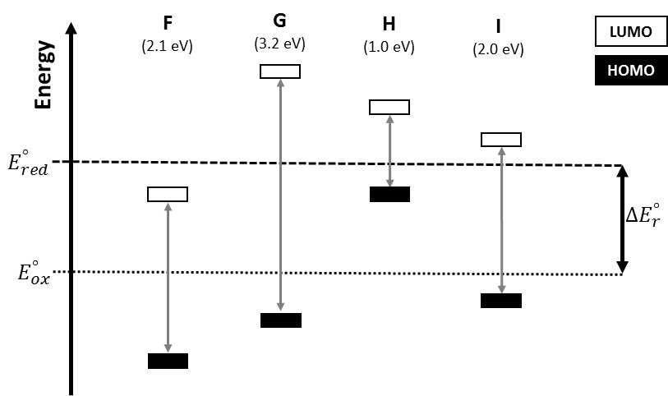

1. Which materials could be used as photocatalysts for the reaction outlined in the diagram?
2. Calculate the maximum wavelengths (in nm) of irradiation sources needed to excite your chosen materials. Based on your results, decide whether you can or cannot use UV and/or VIS light for the irradiation.

Problem 8. Fuel cells

Let us consider a classical hydrogen cell with porous electrodes. Such electrodes are permeable to gases and the cathode also to liquid water. The cathode is fed with oxygen and the anode with hydrogen. The produced water is led out from the cathode compartment. The space between the electrodes is separated by a membrane which is permeable only to H+ ions, so that they can conduct the electric current. Such a fuel cell is quite efficient as there is no other way for hydrogen and oxygen to react except for electron-transfer via electrodes and H+ exchange through the membrane. Assume all gases behave as ideal. In this task, assume standard temperature 298 K and standard pressure 1 bar.

8.1 Determine the standard electromotive force (EMF) of the above described fuel cell working at 298 K with 1 bar hydrogen and 1 bar oxygen. Assume that water is produced in the liquid state.

8.2 Determine the standard EMF of the above described fuel cell working at 298 K with 1 bar hydrogen and 1 bar oxygen. Assume that water is produced in the gas state.

8.3 Calculate the ideal thermodynamic efficiency (thermodynamic or maximum or ideal efficiency is the ratio between the maximum extractible work and the heating value) of the fuel cells described in previous questions at (a) the standard temperature of 298 K and (b) 373 K. Neglect the enthalpy and entropy temperature dependence in all the calculations.

It is possible to construct a fuel cell very similar to the one described above, but working with butane and oxygen.

8.4 Write the balanced chemical equations for the cathode and anode half-reaction.

8.5 Calculate the EMF of the butane–oxygen fuel cell. Assume that butane is fed to the electrodes at the standard temperature and 1 bar and that it reacts with oxygen at 1 bar. Assume that water is produced in the liquid state.

8.6 Calculate the ideal thermodynamic efficiency of the butane fuel cell.

A modified construction of the butane fuel cell uses an oxide-conducting electrolyte, in which the following electrode half-reactions occur:

O2 + 4 e− → 2 O2−

4 CO2 + 5 H2O + 26 e− → C4H10 + 13 O2−

8.7 Determine the standard EMF of this modified butane fuel cell with an oxide-conducting electrolyte.

Another fuel cell works with the formal combustion of methanol. The EMF of such a cell at the standard temperature of 298 K is 1.21 V, and at 373 K it drops by 10 mV.

8.8 Write balanced chemical equations for the cathode and anode half-reaction. Write also the overall reaction that takes place in the methanol fuel cell.

8.9 Write down the Nernst equation for the EMF of this cell. Choose the appropriate standard states for the reactants and products.

8.10 Calculate the standard reaction enthalpy and entropy of the reaction taking place in the methanol fuel cell related to lowest integer coefficients in the chemical reaction involved in the fuel cell.

*Hint:* Use the van ’t Hoff equation.

Useful data:

Δf*H°*(H2O(l)) = −286 kJ mol−1

Δf*H°*(H2O(g)) = −242 kJ mol−1

Δf*H°*(CO2(g)) = −393 kJ mol−1

Δf*H°*(C4H10(g)) = −126 kJ mol−1

*S°*(H2O(l)) = 70 J K−1 mol−1

*S°*(H2O(g)) = 189 J K−1 mol−1

*S°*(H2(g)) = 131 J K−1 mol−1

*S°*(O2(g)) = 205 J K−1 mol−1

*S°*(C(s)) = 6 J K−1 mol−1

*S°*(CO2(g)) = 214 J K−1 mol−1

Δf*G°*(C4H10(g)) = −17 kJ mol−1

Problem 9. Acid-base equilibria in blood

Acid-base homeostasis is one of the most strictly regulated systems in living organisms. Blood buffers are responsible for the short-term stability of pH. The most important one is the bicarbonate buffer, the components of which are further regulated by the lungs and kidneys.

9.1 The daily production of acids in our body is about 60 mmol released into 6 dm3 of blood. For simplification, consider the blood bicarbonate buffer as a closed system initially containing only bicarbonate buffer with pH = 7.4. The partial pressure of CO2 is *p*(CO2) = 5.3 kPa. Calculate the pH at 37 °C, provided that the above-mentioned acidic burden is buffered by the bicarbonate buffer at physiological conditions.

9.2 However, blood is best considered to be an open system, taking into account that the partial CO2 pressure is maintained at a constant level by respiration. Calculate the final pH for the bicarbonate buffer under the same conditions as described in task 9.1, assuming that *p*(CO2) does not change upon the addition of acids. Does the pH value fall into the physiologic range? Explain.

9.3 During cardiac surgery, patients are cooled down to hypothermia in order to prevent brain damage and to slow down their metabolism. Calculate pH at 20 °C (under the conditions of hypothermia), considering that *p*(CO2) and the concentration of bicarbonate remain unchanged.

The importance of pH regulation in a narrow window can be illustrated by its influence on other physiological networks, for example, oxygen transport mediated by red blood cells containing haemoglobin. Haemoglobin has lower affinity to oxygen in tissues with a lower value of pH.

9.4 During physical activity, pH in muscles decreases due to anaerobic metabolism. In lungs, on the other hand, CO2 is removed from the bloodstream. How do these processes influence the haemoglobin-mediated oxygen transport?

Data for calculations:

Dissociation constants of dissolved carbon dioxide: p*K*a (37 °C) = 6.1, p*K*a (25 °C) = 6.35

Enthalpy of vaporization: Δ*H*vap(CO2, blood) = 19.95 kJ mol−1

Henry’s solubility of CO2 in blood at 37 °C: *Hcp*(CO2, 37 °C, blood) = 2.3 × 10−4 mol m−3 Pa−1

Consider ideal behaviour and the concentration of carbonic acid [H2CO3] = 0.

Problem 10: Ion exchange capacity of a cation exchange resin

Ion exchange resins are porous materials, typically used in the form of small beads, with surface functional groups capable of ion exchange. As the binding of ions from a solution occurs, other ions are released from the resin. For example, the binding of cations from a sample of sea water is accompanied by the release of the corresponding amount of hydrogen ions originally bound to the sulfonyl acid groups on the surface of a cation exchange resin.

Let us have a look at the following cation exchange resin – catex **A**. Since *n* is very large, the terminal hydrogen atoms can be neglected in the following calculations.



Structure of catex **A**.

10.1 Calculate the mass percentage of sulfur and carbon.

10.2 Calculate the theoretical ion exchange capacities *Q*m given separately by SO3H groups   
(a strong catex) and COOH groups (a weak catex) in mmol g−1 of the dry catex.

10.3 Calculate the total theoretical ion exchange capacity, *Q*m,total, in mmol g−1.

Frequently, ion-exchange resins become swollen when hydrated, i.e. the volume of the beads changes significantly due to the hydration of highly polar ion-exchange functional groups.

10.4 Calculate the total ion exchange capacity, *Q*V,total, in mmol cm−3 of a swollen resin. The ratio of void volume to the total volume is *ε* = 0.48, the density of the swollen resin is   
*ρ* = 1.28 g cm−3 and the mass ratio of water bound to a resin is *w* = 0.45.

Problem 11. Weak and strong cation exchange resin

The total cation exchange capacity of catex **B** has been determined experimentally by the following procedure. The volume of 4 cm3 of swollen catex was rinsed with the excess of sodium chloride solution to get a resin with sodium cations at all cation exchange sites. Afterwards, all unbound sodium cations were removed by rinsing with water. Next, the column was rinsed with a solution of acetic acid and all the effluent was collected in a 1 000 cm3 volumetric flask which was then filled with water to the mark (solution A). During this procedure, H+ ions were bound to all weak exchange sites and to some strong exchange sites. Subsequently, the column was rinsed with water to remove the excess acetic acid. In the next step, the column was rinsed with a neutral solution of MgSO4 and all the effluent was collected in a 500 cm3 volumetric flask which was then filled with water to the mark (solution B). In this case, Mg2+ was bound to all strong exchange sites.



Structure of catex **B** (R = H, COOH, SO3H).

The amount of sodium ions in 100 cm3 of solution A was determined by direct potentiometry with a sodium ion-selective electrode (ISE); the measured potential was *E*1 = −0.2313 V, whereas the corresponding potentials of the electrode in the solutions of *c*(Na+) = 10.0 mmol dm−3 and *c*(Na+) = 0.100 mmol dm−3 were *E*2 = −0.2283 V and *E*3 = −0.3466 V, respectively.

The amount of sodium ions in 100 cm3 of solution B was determined by the same procedure as described above. In this case, the measured potential of the electrode in solution B was   
*E*4 = −0.2534 V. The concentration of hydrogen ions in 100 cm3 of solution B was determined by alkalimetry. The volume of sodium hydroxide of *c* = 0.1000 mol dm−3 at the equivalence point was 12.50 cm3.

All potentials were measured at a temperature of 298 K.

*Hint:* For the determination of sodium ion concentration use the equation *E* = *k* + *S* log10[Na+], where *E* is the potential of ISE and *k* and *S* are constants.

11.1 Calculate the ion exchange capacities of the catex, *Q*V, which correspond to sulfonyl and carboxyl ion exchange groups, respectively. Provide the results in mmol cm−3.

11.2 Calculate total ion exchange capacity, *Q*V,total, in mmol cm−3.

Problem 12: Uranyl extraction

Bis(2-ethylhexyl) hydrogen phosphate (di-(2-ethylhexyl)phosphoric acid, DEHPA) is used in the extraction of uranyl ions from an aqueous solution to an organic solvent. This water-to-kerosene extraction is known as the “Dapex process”.

DEHPA (HA)

* Is a weak acid that is partially dissociated in water, with a dissociation constant

|  |  |
| --- | --- |
| $$HA⇌A^{-}+H^{+}$$ | $$K_{a,HA}=\frac{{[A^{-}]}_{aq}×{[H^{+}]}_{aq}}{{[HA]}_{aq}}={3.16×10}^{-4}$$ |

* Can be extracted to kerosene with a distribution constant

|  |
| --- |
| $$K_{D,HA}=\frac{{[HA]}_{org}}{{[HA]}_{aq}}={1.89×10}^{2}$$ |

* Forms a hydrogen-bonded dimer in non-polar organic solvents, with a dimerization constant

|  |  |
| --- | --- |
| $$2HA⇌{(HA)}_{2}$$ | $$K_{p,HA}=\frac{{[{(HA)}_{2}]}_{org}}{{[HA]}_{org}^{2}}={2.14×10}^{4}$$ |

* When dissociated in an aqueous solution, it forms a neutral compound with the uranyl ion in a ratio of 2:1 (Note: In real systems, the structure of the neutral compound can vary).

|  |  |
| --- | --- |
| $${2A^{-}+UO}_{2}^{2+}⇌{UO}_{2}A_{2}$$ | $${}_{2,{UO}_{2}A_{2}}=\frac{{[{UO}_{2}A_{2}]}_{aq}}{{[A^{-}]}_{aq}^{2}×{[{UO}_{2}^{2+}]}_{aq}}={4.31×10}^{11}$$ |

This neutral compound can be extracted to kerosene with a distribution constant

|  |
| --- |
| $$K_{D,{UO}_{2}A_{2}}=\frac{{[{UO}_{2}A_{2}]}_{org}}{{[{UO}_{2}A_{2}]}_{aq}}={1.69×10}^{2}$$ |

Assume that:

* The concentration of DEHPA before the extraction: *c*HA,org,0 = 0.500 mol dm−3 and   
  *c*HA,aq,0 = 0.000 mol dm−3.
* , therefore it is possible to omit the concentration of UO2A2 in the mass balance of HA in both the aqueous and organic phase.
* The volume ratio is *V*org/*V*aq = 1.00.

Uranyl ions also form hydroxo complexes

|  |  |  |
| --- | --- | --- |
| $${UO}_{2}^{2+}+i{OH}^{–}⇌{[{UO}_{2}{(OH)}_{i}]}^{2–i} where i=1–4$$ | |  |
| $${}_{i,[{UO}_{2}({OH)}_{i}]}=\frac{{[{{UO}_{2}(OH)}_{i}^{2-i}]}_{aq}}{{[{UO}_{2}^{2+}]}_{aq}{×[{OH}^{-}]}_{aq}^{i}}$$ | Note: For clarity square brackets as a symbol for a complex were omitted in the numerator. | |

with decimal logarithms of the overall complexation constants log *β*1 = 10.5, log *β*2 = 21.2,   
log *β*3 = 28.1, log *β*4 = 31.5.

12.1 Calculate the yield of uranyl ions extraction from a nitric acid solution with   
 = 2.00 × 10−2 mol dm−3.

*Hint*: First, calculate the concentration of DEHPA in the organic phase after reaching the equilibrium with the aqueous phase, i.e. calculate [HA]org. To do this, use the mass balance of HA. Consider the different forms of DEHPA in both the organic and aqueous solution.

12.2 Calculate the yield of uranyl ions extraction from a sodium hydroxide solution with   
 = 2.00 × 10−4 mol dm−3.

*Hint*: Use the same procedure as in task 12.1.

In both cases, consider only the equilibria that have been mentioned so far.

Problem 13. Determination of active chlorine in commercial products

Traditional Czech and Slovak bleaching and disinfecting products include a commercially available solution called “SAVO”. The strength of products like SAVO is commonly expressed as the content of active (or free) chlorine. The active chlorine value determination is usually carried out by adding an excess of potassium iodide to a sample and titrating the equivalent of released iodine with the standard sodium thiosulfate solution.

13.1 Consider a reaction (i) between chlorine and water giving products **A** and **B** and a reaction (ii) between sodium hypochlorite and water giving products **A** and **C**. Write the chemical equations for both reactions. Which form of **A** will be dominant in an alkaline aqueous solution?

13.2 Commercial SAVO contains 22.4 g dm−3 of active chlorine. What is the corresponding molar concentration of sodium hypochlorite in SAVO?

13.3 For the determination of sodium hypochlorite, 10.00 cm3 of SAVO (density 1.070 g cm−3) were transferred into a 250 cm3 volumetric flask, distilled water was added to the mark and the solution was mixed. An aliquot of 10.00 cm3 of the solution was transferred into a titration flask and diluted with approx. 50 cm3 of distilled water. After the addition of 5 g of potassium iodide, the released iodine was titrated by 10.15 cm3 of 0.0503 mol dm−3 standard sodium thiosulfate solution to reach the equivalence point. Calculate the mass percentage of sodium hypochlorite in the original SAVO product.

Problem 14. Chemical elements in fireworks

Low explosive pyrotechnics used in fireworks contain inorganic elements in the fuel or as oxidizers or additives. Typical fuels are based on metal or metalloid powders and typical oxidizers are based on perchlorates, chlorates and nitrates with added alkali, alkaline earth and some transition metals. All these substances can easily be determined in an analytical laboratory.

14.1 Explain the principle of qualitative flame tests used for the detection of sodium, barium and lithium ions dissolved in aqueous solution. Which flame colours are associated with these elements?

Ions of alkaline earth metals and transition metals can by determined by complexometric titrations with EDTA, which is a weak acid with p*K*a1 = 2.00, p*K*a2 = 2.67, p*K*a3 = 6.16 and p*K*a4 = 10.26.

14.2 Sketch the structure of a metal–EDTA complex. Which forms of EDTA will be present in a solution with a pH = 10 at molar concentration higher than 0.5% of the total?

The determination of calcium, strontium and barium ions by the reaction with EDTA is often performed in the presence of an ammonium buffer, which keeps the pH of the solution around 10.

14.3 What is the chemical composition of an ammonium buffer? What is the role of an alkaline pH in these reactions?

A combustible mixture used in fireworks (containing zinc, magnesium, lead, and no other multivalent ions) in a paper cartridge was analyzed in the following three steps:

1. The sample (0.8472 g) was dissolved and an excess of cyanide was added to mask the zinc in solution. This mixture was titrated with 0.01983 mol dm−3 EDTA and *V*1 = 35.90 cm3 was required to reach the equivalence point.
2. Next, 2,3-disulfanylpropan-1-ol (DMP) was added and the released EDTA was titrated with 12.80 cm3 of 0.01087 mol dm−3 of Mg2+ standard solution to reach the equivalence point.
3. Finally, formaldehyde was introduced to release the zinc ions, which were subsequently titrated with *V*2 = 24.10 cm3 of 0.01983 mol dm−3 EDTA to reach the equivalence point.

14.4 Write both ionic equations for the masking and the releasing of the zinc ions.

14.5 Explain the role of the DMP addition.

14.6 Calculate the mass (in mg) of all three elements in 1 g of the original sample.

14.7 10.00 cm3 of 0.0500 mol dm−3 Ca2+ solution was mixed with 50.00 cm3 of 0.0400 mol dm−3 EDTA in a 100 cm3 volumetric flask and after the pH was set to 6, the flask was filled up to the mark with distilled water. Calculate the concentration of free Ca2+ ions in the solution. Decimal logarithm of the stability constant for the complex of Ca2+ ions with EDTA is 10.61. Consider only the equilibria that have been mentioned so far.

Problem 15. Colours of complexes

Due to the absorption of a part of the light in the visible region of the spectrum, transition metal complexes are often coloured. In this problem, we shall focus on simple cases in which this absorption is caused by d-d transitions.

**Titanium complex**

Titanometry is a reductometric method that uses blue-violet aqueous solution of titanium(III) chloride. The colour of the solution is caused by the presence of octahedral particles [Ti(H2O)6]3+. The spectrum features absorption band with a maximum at 20 300 cm−1:

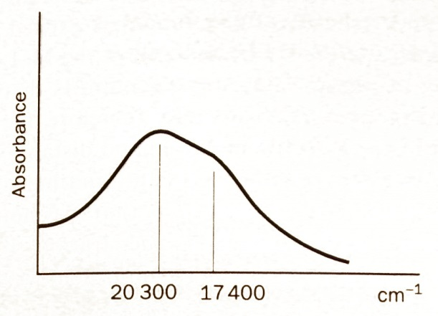

15.1 Draw the electron configuration of the ground and the excited state of the [Ti(H2O)6]3+ ion into the schemes.

 

15.2 Predict the colour of the complex. Consider the absorption of the light at 20 300 cm−1.

15.3 In fact, there is a second absorption band in the spectrum. This band shows itself as a shoulder at 17 400 cm−1. Explain the colour of the complex based on the actual spectrum.

The presence of two bands in the spectrum is caused by the fact that the [Ti(H2O)6]3+ particle is not a regular octahedron; it is rather an elongated octahedron. This elongation causes further splitting of the d-orbitals.

15.4 Draw the electron configuration of the ground (a) and the excited states (b) and (c) into the schemes.



**Cobalt complexes**

The K3[CoF6] complex is a rare example of a high-spin cobalt(III) complex. The fluorination of cobalt(II) chloride yields cobalt(III) fluoride (1). Its reaction with potassium fluoride yields the K3[CoF6] complex (2). This reaction is carried out in non-aqueous media (HF) because cobalt(III) fluoride oxidizes water (3).

15.5 Write the equations of reactions (1) to (3).

The [Co(NH3)6]Cl3 complex is prepared by bubbling air through ammoniacal solution of cobalt(II) chloride and ammonium chloride under activated carbon catalysis.

15.6 Write the equation of reaction (4).

15.7 The common name of the [Co(NH3)6]Cl3 complex is luteochloride. It has two absorption bands at the wavenumbers of 21 050 cm−1 and 29 400 cm−1 in the near UV and visible part of the spectrum. Predict the colour of the complex. Find the relation between the colour and its common name.

15.8 Explain why the K3[CoF6] complex is high-spin and paramagnetic, while the [Co(NH3)6]Cl3 complex is low-spin and diamagnetic.

High-spin complexes with the d6 configuration have spectra like those of d1 configuration. The [CoF6]3− ion has the shape of an elongated octahedron.

15.9 Draw the electron configuration of the ground state and excited states provided that the net spin of the particle is not changed when excited.

15.10 The wavenumbers of the bands corresponding to these excitations are 11 400 cm−1 and 14 500 cm−1. Predict the colour of the [CoF6]3− ion.

Problem 16. Iron chemistry

For historical, political, economic, technological as well as biological and biochemical reasons, iron is one of the most important elements on the periodic table. In the following task some general aspects concerning the chemistry of iron will be discussed from the viewpoint of physical chemistry.

First, let us explore the available redox states of iron in detail.

16.1 Sketch the Latimer diagram for iron species (pH 0), using the following standard redox potentials: *E*°(FeO42−, H+/Fe3+) = 1.90 V, *E*°(Fe3+/Fe2+) = 0.77 V, *E*°(Fe2+/Fe) = −0.44 V. Calculate also the redox potentials for couples FeO42−/Fe2+, FeO42−/Fe and Fe3+/Fe and add them to the diagram.

16.2 Determine the voltage equivalents for individual redox states of iron and plot the Frost diagram. Decide whether the mixture of FeO42− and Fe2+ at pH = 0 will interact spontaneously.

Another frequently used type of redox (and acid-base) equilibrium plot is the Pourbaix diagram. It involves individual pH-dependent redox potentials. Let us look into the problem more deeply.

For simplicity, activities will be replaced with equilibrium concentrations even though such description does not always adequately correspond to reality. Potentials are given in volts. The notation of the cationic species in the text and equations ignores the water molecules in the coordination sphere, i.e. Fe2+ means [Fe(H2O)6]2+, [Fe(OH)]+ means [Fe(H2O)5(OH)]+, etc. Therefore, e.g. [Fe(OH)3] must not be considered as solid iron(III) hydroxide but it denotes dissolved neutral [Fe(OH)3(H2O)3] complex species.

**Each line in the Pourbaix diagram originates from the assumption that the activities (concentrations) of both species participating in the given equilibrium are equal.**

(a) If only redox equilibria are considered, the resulting plot contains horizontal lines (Figure 1a). A typical example is the redox pair Tl+/Tl with *E*° = −0.34 V (in the pH range 0 to 12; in more basic solutions hydroxido complexes are formed). The mathematical expression of the given line is simple, eq. (1):

*line a* The potential at which activities/concentrations of Tl+ and Tl(s) are equal, i.e. *a*(Tl,s)/[Tl+] = 1:

(Tl+/Tl): *E* = *E*° − (0.059 / *n*) log(*a*(Tl,s) / [Tl+]) = −0.34 − 0 = −0.34 V (1)

(b) When the same approach is applied to a system in which only protolytic (e.g. hydrolytic) processes occur (with no redox contribution within the selected potential limits) leads to vertical lines (Figure 1b). For instance, the stepwise hydrolysis of Ga3+ ion occurs according to four overall stability constants of complex hydroxido species, eq. (2–5).

Ga3+ + OH− = [Ga(OH)]2+, log*β*1 = [Ga(OH)2+] / ([Ga3+] × [OH−]) = 11.4 (2)

Ga3+ + 2 OH− = [Ga(OH)2]+, log*β*2 = [Ga(OH)2+] / ([Ga3+] × [OH−]2) = 22.1 (3)

Ga3+ + 3 OH− = [Ga(OH)3], log*β*3 = [Ga(OH)3] / ([Ga3+] × [OH−]3) = 31.7 (4)

Ga3+ + 4 OH− = [Ga(OH)4]−, log*β*4 = [Ga(OH)4−] / ([Ga3+] × [OH−]4) = 39.4 (5)

The final expressions (6–9) can be derived and calculated as follows:

*line b* pH at which concentrations of Ga3+ and [Ga(OH)]2+ are equal, i.e. pH = p*K*a of [Ga(H2O)6]3+ leading to the formation of [Ga(H2O)5OH]2+:

(Ga3+/[Ga(OH)]2+): pH = p*K*w − log*β*1 = 14.0 − 11.4 = 2.6; (6)

and, analogously:

*line c* ([Ga(OH)]2+ / [Ga(OH)2]+):

pH = p*K*w − log*β*2 + log*β*1 = 14.0 − 22.1 + 11.4 = 3.3 (7)

*line d* ([Ga(OH)2]+ / [Ga(OH)3]):

pH = p*K*w − log*β*3 + log*β*2 = 14.0 − 31.7 + 22.1 = 4.4 (8)

*line e* ([Ga(OH)3] / [Ga(OH)4]−):

pH = p*K*w − log*β*4 + log*β*3 = 14.0 − 39.4 + 31.7 = 6.3 (9)

(c) If both redox and protolytic equilibria are involved, the resulting line is sloping. One useful example is the oxygen reduction (10) and hydrated proton reduction (11), which is shown in Figure 1c. The analytical expressions of *lines f* (12) and *g* (13) have an identical slope value, i.e. both lines are parallel and they define the area of water redox stability with respect to the reduction affording H2(g) and oxidation to O2(g).

O2 + 4 H+ + 4 e− → 2 H2O, *E*° = 1.23 V (10)

2 H+ + 2 e− → H2, *E*° = 0 V (def.) (11)

*line f* (O2,H+/H2O):

*E* = *E*° − (0.059 / *n*) × log[*a*2(H2O,l) / (*a*(O2,g) × [H+]4)] = 1.23 − 0.059 × pH (12)

*line g* (H+/H2):

*E* = *E*° − (0.059 / *n*) × log[*a*(H2,g) / [H+]2] = −0.059 × pH (13)

|  |  |  |
| --- | --- | --- |
|  |  |  |
| **(a)** | **(b)** | **(c)** |

**Figure 1.** Pourbaix diagrams of **(a)** Tl+/Tl system, **(b)** Ga3+/[Ga(OH)*n*](3−*n*)+ system   
and **(c)** H2/H2O/O2 system.

Now, let us turn back to iron chemistry.

16.3 The construction of the Pourbaix diagram for all iron species is rather tedious. Thus, a rough form of the result valid for metallic iron and dissolved iron species between pH 0 and 14 is provided in Figure 2.

1. All the lines divide the area of the diagram into many zones. Deduce which species prevail in the individual zones in Figure 2 and fill the answers into the diagram.
2. Using the data from 16.1 together with Table 1, derive and write down the conditions for horizontal *lines 11* and *17*, and vertical *lines 2* and *5*.

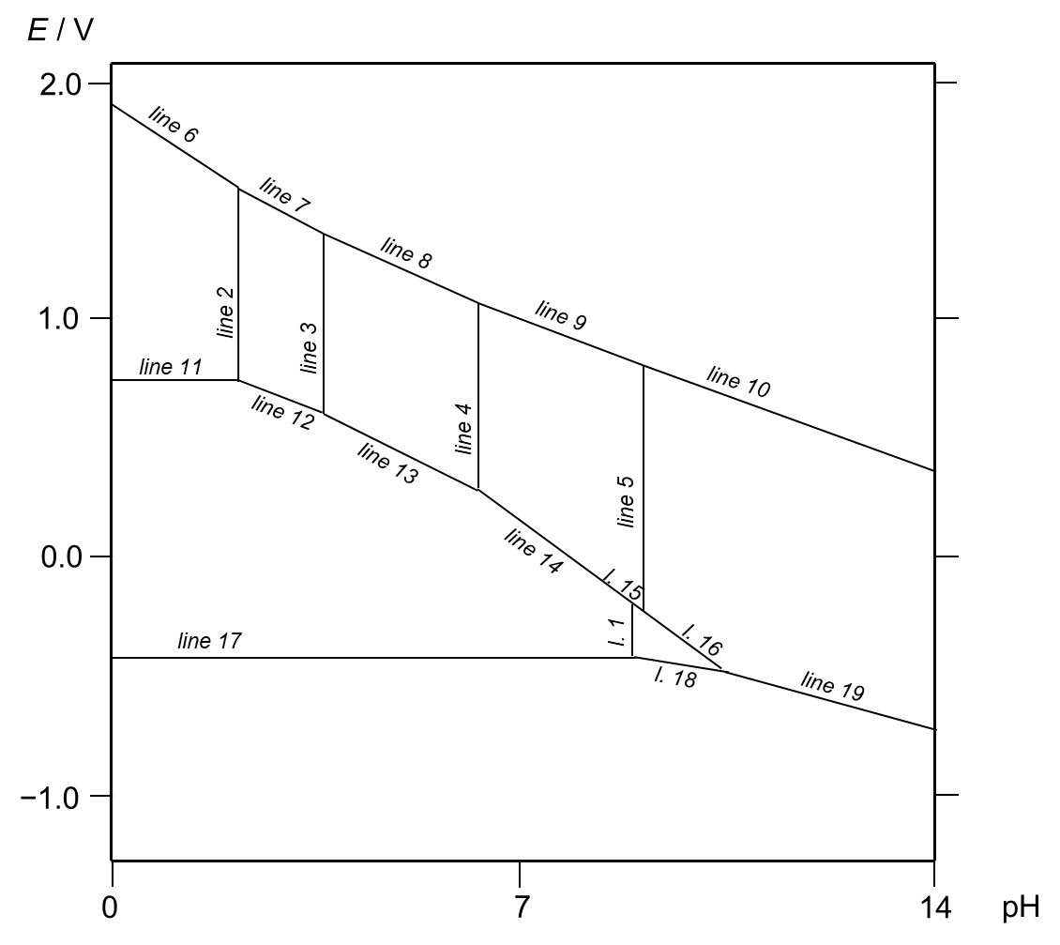

**Figure 2.** Pourbaix diagram for metallic iron and dissolved iron species in water.

**Table 1**: Overall stability constants *βn* of ferrous / ferric hydroxido complexes.

|  |  |  |
| --- | --- | --- |
|  | log *βn* (Fe2+ + *n* OH−) | log *βn* (Fe3+ + *n* OH−) |
| *n* = 1 | 4.5 | 11.8 |
| *n* = 2 | – | 22.3 |
| *n* = 3 | – | 30.0 |
| *n* = 4 | – | 34.4 |

1. As an example of sloping lines, derive the equation for *line 6* and determine the coordinates [pH, *E*] of its intersection with *lines 2* and *7*.
2. Ferrate(VI) anion is a stronger oxidizing agent than oxygen itself (compare *line f* in Figure 1c with the stability region of the ferrate ion in Figure 2), and thus is stable only in an extremely basic region, in which the potentials of O2/H2O and FeO42−/[Fe(OH)*n*](3−*n*)+ are comparable. Thus, in general, the ferrate ion is not stable in aqueous solutions and oxidizes water to oxygen. Suggest a method for generating a ferrate ion. Write the corresponding stoichiometric equation.

It is generally known that ferric compounds tend to hydrolyze more readily than ferrous compounds.

16.4 Discuss all the species involved in the Pourbaix diagram (Figure 2) in terms ion size and surface charge density concept and explain which ligands would best match each   
metal-ion centre.

Thermodynamic, kinetic, spectroscopic and magnetic properties are closely related to the electronic structure of the individual species. Since iron is a d-block metal, crystal field and ligand field theories help us to understand the situation. Concerning the determination of the electron configuration in the frame of split d-orbital levels, the most useful qualitative concept is the spectrochemical series.

16.5 Write down the magnetic state of the following species (high/low-spin state): [Fe(H2O)6]2+, [Fe(CN)6]4−, [Fe(H2O)6]3+, [Fe(H2O)5OH]2+, [Fe(CN)6]3−. In the approximation of Oh symmetry, calculate the LFSEs and express the results in the units of ligand field strength Δo and electron-pairing energy P.

16.6 Figure 3 below shows the UV-Vis spectra of an orange-brown solution of FeCl3 containing a [Fe(H2O)5OH]2+ cation and of a nanosuspension of the Prussian blue (which can be approximated as Fe4[Fe(CN)6]3). The spectra are shown in an unknown order. Assign each compound to the respective spectrum.

|  |  |
| --- | --- |
|  |  |
| **(a)** | **(b)** |

**Figure 3.** Spectra of FeCl3 and Fe4[Fe(CN)6]3 (in unknown order).

Problem 17. Cyanido- and fluorido-complexes of manganese

Manganese forms the highest number of oxidation states among the first-row transition metals. This task deals with the synthesis and electronic structure of manganese cyanido- and   
fluorido-complexes in oxidation states +I to +IV.

**Oxidation state +I**

Metallic manganese reacts only slowly with water. It dissolves readily in 2 M deaerated solution of NaCN to give colourless, diamagnetic Na5[Mn(CN)6] (1).

17.1. Write a balanced equation (1).

17.2 Draw the splitting diagram for the complex anion and fill in the electrons.

**Oxidation state +II**

Soluble manganese(+II) compounds (e.g. chloride, nitrate, sulfate) are common starting materials for the preparation of manganese complexes. Mn2+(aq) in deaerated aqueous solution reacts with excess CN− to give a blue ion [Mn(CN)6]4− with a magnetic moment corresponding to one unpaired electron.

17.3 Mn2+(aq) ion can be considered as a high-spin hexaaqua-complex. Draw the splitting diagram, fill in the electrons and predict the number of unpaired electrons in the complex.

17.4 Draw the splitting diagram for [Mn(CN)6]4− and fill in the electrons.

**Oxidation state +III**

Red [Mn(CN)6]3− is an example of a rare low-spin manganese(+III) complex. It can be prepared by three different methods:

1. Stream of air is bubbled through the solution of a manganese(+II) salt and excess of cyanide (2).
2. [Mn(CN)6]4− is oxidized by 3% solution of hydrogen peroxide (3).
3. Manganese(+II) chloride is oxidized by nitric acid in excess phosphoric acid (NO is formed) (4). The green-grey precipitate thus formed is filtered off and dissolved in potassium cyanide solution at 80 °C (non-redox reaction) (5).

17.5 Write balanced equations (2)–(5), (2) and (3) in an ionic form.

17.6 Draw the splitting diagram for [Mn(CN)6]3− ion and fill in the electrons.

Violet complex K3[MnF6] can be prepared by dissolving manganese dioxide in KHF2 aqueous solution (6).

17.7 Write a balanced equation (6).

Other manganese(+III) fluorido-complexes exist with seemingly different coordination numbers: Na2[MnF5], Cs[MnF4]. In reality, the coordination number of Mn atom is 6 in both cases. Octahedral units [MnF6]oct in the structure of these salts are interconnected by bridging F atoms.

17.8 Draw the splitting diagram for the octahedral species [MnF6]3− and fill in the electrons.

17.9 Predict the structure of anionic 1D-chains present in Na2[MnF5].

17.10 Predict the structure of anionic 2D-layers present in Cs[MnF4].

**Oxidation state +IV**

The oxidation of a [Mn(CN)6]3− ion by nitrosyl chloride gives a [Mn(CN)6]2− ion. When irradiated with sunlight, this ion undergoes reductive photolysis to give a tetrahedral [Mn(CN)4]2− ion.

17.11 Draw the splitting diagram for [Mn(CN)6]2− and fill in the electrons.

17.12 All the regular tetrahedral complexes are high-spin. Why? Draw the splitting diagram for [Mn(CN)4]2− and fill in the electrons.

Yellow fluorido-complex K2[MnF6] can be prepared by reducing KMnO4 with hydrogen peroxide in the presence of KHF2 and HF (7).

17.13 Write a balanced equation (7).

17.14 The electronic structure of [MnF6]2− can be described qualitatively by the same splitting diagram as [Mn(CN)6]2−. Why?

Interestingly, complex K2[MnF6] can be used for non-electrolytic fluorine preparation. Upon heating, it reacts with SbF5 to give K[SbF6], MnF2 and fluorine (8).

17.15 Write a balanced equation (8).

Problem 18. The fox and the stork

A fox one day invited a stork to dinner, and being disposed to divert himself at the expense of his guest, provided nothing for the entertainment but some thin soup in a shallow dish. This the fox lapped up very readily, while the stork, unable to gain a mouthful with her long narrow bill, was as hungry at the end of dinner as when she began. The fox meanwhile professed his regret at seeing her eat so sparingly and feared that the dish was not seasoned to her mind.

The stork said little, but begged that the fox would do her the honour of repaying her visit. Accordingly, he agreed to dine with her on the following day. He arrived true to his appointment and the dinner was ordered forthwith.

When the meal was served up, the fox found to his dismay that it was contained in   
a narrow-necked vessel, down which the stork readily thrust her long neck and bill, while he was obliged to content himself with licking the neck of the jar. Unable to satisfy his hunger, he retired with as good a grace as he could, observing that he could hardly find fault with his entertainer, who had only paid him back in his own coin.

[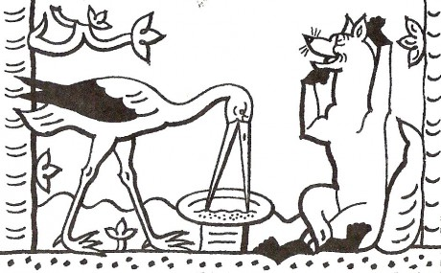](http://www.muchlanek.estranky.cz/fotoalbum/tvorenicko/omalovanky/z-pohadek-pro-nejmensi/pohadkove-bytosti/ostatni-pohadkove-bytosti/liska-a-cap-02.-.html) [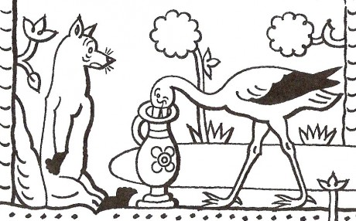](http://www.muchlanek.estranky.cz/fotoalbum/tvorenicko/omalovanky/z-pohadek-pro-nejmensi/pohadkove-bytosti/ostatni-pohadkove-bytosti/liska-a-cap-01.-.html)

An alternative end of the fable (instead of the grey sentence) could be:

However, as the fox was very clever, he took a look around and found a solution to his problem. There were many pebbles lying around. The fox did not hesitate even for a moment and started to throw them inside the jar of soup. The stork was shaking her head in confusion as the fox kept throwing the pebbles in, until the moment that the surface of the soup reached the brim of the jar. Then the fox turned to the stork with a smirk on his face and said: “Of course I will taste it,” and started to eat the soup.

A minimum volume of the soup in the jar is necessary for the fox to succeed. This volume is related to the total volume of the pebbles eventually present in the jar. This total volume is related to the number, size and way of arrangement of the pebbles.

Let us approximate the situation by a geometrical model:

* The jar is approximated as a perfect cylinder with a diameter of 10.0 cm and a height of 50.0 cm.
* A pebble is approximated as a perfect hard-sphere.
* All the spheres have the same diameter.
* The spheres are arranged as close as possible so that they touch each other.
* The soup is approximated by water.
* All pebbles are fully inside the jar (i.e. no part of any pebble is above the rim of the cylinder).

**Large stones**

Let us consider the radius of the sphere *r* = 5 cm.

18.1 Calculate the maximum number of spheres that fit into the cylinder.

18.2 Calculate the fraction (in %) of the cylinder volume occupied by this number of spheres.

18.3 Calculate the free volume (in cm3) among the spheres that can be filled with water.

**Pebbles**

Let us consider an arrangement in which 7 spheres in the first (base) layer just fit into the cylinder:



18.4 Calculate the radius of the sphere (in cm).

In the following questions, consider an arrangement in which all the higher layers copy the positions of the spheres in the base layer.

18.5 Calculate the maximum number of layers that fit in the cylinder.

18.6 Calculate the maximum number of spheres that fit in the cylinder.

18.7 Calculate the fraction (in %) of the cylinder volume occupied by this number of spheres.

18.8 Calculate the free volume (in cm3) among the spheres that can be filled with water.

In the following questions, consider an arrangement in which each even layer consists of 3 spheres and each odd layer copies the positions of the spheres in the base layer:



18.9 Calculate the maximum number of layers that fit in the cylinder.

18.10 Calculate the maximum number of spheres that fit in the cylinder.

18.11 Calculate the fraction (in %) of the cylinder volume occupied by this number of spheres.

18.12 Calculate the free volume (in cm3) among the spheres that can be filled with water.

**Sand**

Let us consider very small spheres with diameter smaller by orders of magnitude than the diameter of cylinder (*r* → 0).

18.13 Calculate the limiting fraction (in %) of the cylinder volume occupied by the spheres.

18.14 Calculate the free volume among the spheres that can be filled with water.

Problem 19. Structures in the solid state

The structure of sodium chloride, NaCl, is one of the basic crystal structure types of ionic compounds. Its face-centred cubic unit cell is shown in Figure 1. The lattice constant of NaCl is *a* = 5.64 Å and the radius of the sodium(I) ion is *r*(Na+) = 1.16 Å.

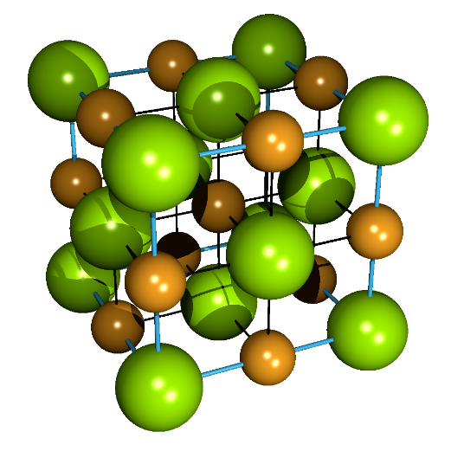

**Figure 1.** Unit cell of NaCl. Colour code: Na+ yellow, Cl– green.

19.1 Calculate the ionic radius of a chloride ion, *r*(Cl−).

Potassium chloride, KCl, crystallizes in the same crystal structure type. The density of solid KCl is *ρ*(KCl) = 1.98 g cm−3.

19.2 Calculate the ionic radius of a potassium ion, *r*(K+).

The structure of ionic compounds can be estimated using relative sizes of the cation and anion, as *r*+/*r*− ratio determines what kind of cavity found in the anionic lattice could be occupied by the cation.

19.3 The ionic radius of a lithium ion is *r*(Li+) = 0.90 Å. Estimate whether LiCl adopts the same crystal structure type as NaCl or not.

Some ionic compounds of divalent ions also crystallize in the crystal structure type of NaCl, for example galena, PbS. Its lattice constant is *a* = 5.94 Å.

19.4 Calculate the density of galena.

Since silver(I) ions can be substituted for lead(II) ions in the structure of PbS, galena is a very important silver ore. To ensure electro-neutrality of the crystal, the decrease in the overall positive charge is compensated by the vacancies of sulphide anions. The composition of such a phase can be expressed by a general formula Pb1−*x*Ag*x*S*y*.

19.5 Derive the value of *y* as a function of *x*.

A sample of silver-containing galena, in which a part of the lead(II) ions are substituted by silver(I) ions and the decrease in charge is compensated by the vacancies of sulphide ions, has a density of 7.21 g cm−3. The lattice constant of this sample is *a* = 5.88 Å.

19.6 Calculate the value of the stoichiometric coefficient *x*.

Zinc blende (sphalerite, ZnS) crystallizes in a different crystal structure type, which is closely related to the structure of diamond. Both types of structures are shown in Figure 2.

|  |  |
| --- | --- |
|  |  |
| **Figure 2.** **(a)** Unit cell of sphalerite.  Colour code: Zn2+ grey, S2− yellow-green. | **(b)** Unit cell of diamond. |

19.7 How many formula units (ZnS) are there in the unit cell of sphalerite?

Heavier elements of group IV (i.e. group 14), silicon and germanium, also adopt the structure of diamond. The radius of elemental germanium is *r*(Ge) = 1.23 Å.

19.8 Calculate the density of solid germanium.

Germanium is a semiconductor similar to silicon. It is used in electro-technology and similarly to silicon, it is also very fragile. Therefore, more flexible isoelectronic gallium arsenide, GaAs, is used in some practical applications. This compound belongs to semiconductors of III–V type (compounds of elements from groups III and V, *i.e.* groups 13 and 15, respectively) and adopts the structure of sphalerite. The lattice constants of Ge and GaAs are very similar, and   
*a*(GaAs) = 5.65 Å. An analogous compound GaP also adopts the structure of sphalerite, but has a smaller unit cell with *a*(GaP) = 5.45 Å.

19.9 Calculate the difference between the radii of P and As in the respective compounds with gallium (GaP versus GaAs).

Problem 20. Cyclobutanes

20.1 Draw all possible isomers of substituted cyclobutanes with the molecular formula C7H14, including enantiomers.

20.2 Mark all the asymmetric carbon atoms in the molecules from question 20.1 with an asterisk.

20.3 List all the compounds from question 20.1 that do **not** show optical activity.

20.4 List all pairs of enantiomers from question 20.1.

Problem 21. Fluorinated radiotracers

Fluorodeoxyglucose, namely the 18F isotopomer 2-deoxy-2-[18F]fluorodeoxyglucose (18F-**FDG**), is a compound used in cancer diagnostics in a technique called positron emission tomography (PET). In this technique, the patient is treated with a radiotracer which is preferentially taken up by cancer cells. Upon radioactive decay, a positron is formed which rapidly annihilates with a nearby electron. A pair of γ-photons flying in opposite directions are produced and detected. This allows for the localization of the tumour with high sensitivity and spatial resolution.



21.1 The isotope 18F is produced by a proton bombardment technique. Which isotope of which element is used for the production of 18F?

Since the amount of 18F-**FDG** used in PET is very low, the dose is defined by units of radioactivity instead of the more commonly used molar concentration.

21.2 What is the amount of 18F-**FDG** (in moles) present in one dose of 300 MBq (3 × 108 s−1)? The half-life of 18F is 109.771 min.

Assume that all molecules of 18F-**FDG** decay to 18O-**glucose**, which eventually undergoes standard biochemical transformation into carbon dioxide and water.



21.3 At what time point will the chemical energy of 18O-**glucose**, produced by the decay of   
18F-**FDG**, be equal to the total energy of γ‑photons not yet released from the remaining   
18F-**FDG**? In other words, at which time point would decomposing all obtained 18O-**glucose** into CO2 and H2O produce the same amount of energy as the radioactive decay of all remaining 18F-**FDG**? The heat of combustion of glucose is 2 800 kJ mol−1.

Nevertheless, 18F-**FDG** is not the only fluorinated radiotracer in use. Compound **1** is a radiotracer used in the diagnostics of Parkinson’s disease (PD). Molecule **1** binds to the dopamine transporter (DAT), a membrane protein characteristic of dopaminergic neurons. Degeneration of this class of neurons is a symptom of PD. Therefore, targeted imaging of neural cells expressing DAT is advantageous in the diagnostics of the neurodegenerative disorder.

A freshly synthesized sample of K18F reacts with ditosylate **A**, producing monofluorinated precursor **B**. Molecule **B** further reacts with amine **2** to give the final radiotracer **1**.

21.4 Propose the structures of tosylates **A** and **B**. What additive **X** is required to render the fluoride anion nucleophilic enough that the reaction runs to completion within minutes?



Amine **2** can be easily produced by a sequence of reactions starting from cocaine (**3**), a natural product from plants of the *Erythroxylaceae* family.

The synthesis starts with acid-catalyzed hydrolysis of cocaine (**3**) leading to compound **C** (C9H15NO3). Subsequent elimination with POCl3 produces, after a methanolic workup, compound **D**. Addition of magnesium-containing reagent **E** to compound **D** provides, after subsequent aqueous workup, precursor **4**. The final step in the synthesis of secondary amine **2** involves demethylation with 1-chloroethyl chloroformate followed by workup with aqueous sodium carbonate.



21.5 Draw the structures of compounds **C** to **E**.

21.6 Compound **4** is not the only stereoisomer which can be formed by the addition of **E** to **D**. Draw the structures of all the stereoisomers which are unwanted side-products of the transformation.

21.7 The mechanism of demethylation of **4** involves the formation of acylated intermediates **F** and **G**, and subsequent liberation of amine **2** with acidified hot methanol. Draw the structures of intermediates **F** and **G**.

Problem 22. Where is lithium?

Aryllithium reagents are key intermediates in the synthesis of a vast number of substances. The preparation of such reagents can be achieved by the reaction of aryl halides with lithium or butyllithium. Another possibility involves an acid-base reaction of aromatic/heteroaromatic compounds with a strong base.



The reaction of substituted iodobenzene **4** with lithium diisopropylamide (LDA) is an example of an aromatic carboxylic acid synthesis via an acid-base reaction known as the halogen dance reaction. In this case, the reaction affords acid **6** as the major product along with trace amount of acid **5**.



22.1 Draw the mechanism for the reaction of general aryl halide **1** with lithium.

22.2 Draw the structures of intermediates **A**, **B**, **C**, and **D** that explain the mechanism of formation of acids **5** and **6**.

22.3 Acid **5** can be prepared by the so-called haloform reaction. Suggest a synthetic route from substrate **E** (C8H3F3I2O) with suitable reagents.

Problem 23. Synthesis of eremophilone

Eremophilone, (–)-**1a**, is a constituent of a commercially available oil with anti-inflammatory and relaxing properties, isolated from the Australian *Eremophila mitchellii* shrub (buddha wood).



The synthesis of enantiomerically pure eremophilone is challenging due to the *cis*-configuration of the two methyl groups and the axial orientation of the isopropenyl group. The synthesis of the corresponding diastereomeric mixture **1** starts from ketone **2**, which is reacted with   
ethane-1,2-diol under acidic conditions to provide compound **A**, followed by regioselective reduction with a borane–THF complex. Oxidative work-up of the borane intermediate yields substance **B**. Its mild oxidation gives product **C**, which is reacted stereoselectively in the next step with an appropriate λ5-alkylidenephosphane (ylide) **D** to furnish compound **3**. Its reduction leads to substance **E**, which reacts with butyl vinyl ether in the presence of mercury acetate to afford compound **4**. Heating of compound **4** results in its rearrangement to compound **F**, which, after deprotection, provides dioxo compound **G**. Final intramolecular aldolization using reagent **H** leads to bicyclic **5** as the key intermediate in the synthesis of eremophilone stereoisomeric mixture (**1**).



23.1 Draw the structures of the products and reagents **A**–**H**.

The key step in the synthesis is a thermal rearrangement of allylic vinyl ether **4**, leading to compound **F**. For the reaction to proceed, compound **4** must adopt appropriate orientation **I** to allow for the subsequent sigmatropic transformation.



23.2 Draw the required orientation of the allylic vinyl ether moiety **I** in compound **4** that enables the sigmatropic transformation. Use curved arrows to show the flow of electrons in the rearrangement step that provides compound **F**. What is the name of the rearrangement?

*Note*: You do not have to draw 3D structures.

This rearrangement typically requires high temperatures, but this is not always an essential requirement. For example, allylic esters, e.g. ester **6**, can also undergo this transformation by first treatment with a strong non-nucleophilic base such as lithium diisopropylamide (LDA) at   
−78 °C to give the corresponding enolate. Subsequent trapping of the enolate with chlorotrimethylsilane yields silyl enol ether **J**. When allowed to warm to room temperature, substance **J** undergoes spontaneous rearrangement to substituted silyl ester **L** through conformation **K**.



23.3 Draw the structures of **J** and **L** and orientation **K** that enables the sigmatropic transformation to proceed. Use curved arrows to show the flow of electrons in the rearrangement step to compound **L**.

*Note*: You do not have to draw 3D structures.

Problem 24. Cinnamon all around

Cinnamon is an important part of many dishes and desserts, including Czech apple strudel, Swedish cinnamon rolls kanelbullar, Indian spicy rice biryani and the popular winter drink mulled wine. There are several compounds in cinnamon which are responsible for its taste and smell, mainly cinnamaldehyde and cinnamic acid and its derivatives. It is noteworthy that   
(*E)*-cinnamaldehyde and cinnamic acid are much more abundant in nature than their respective (*Z*)-isomers. While the former have a honey, cinnamon-like odour, the latter are completely odourless. Let us first explore the syntheses of both stereoisomers of cinnamic acid.



24.1 Draw the formulae of isomeric products **A** and **B**.

24.2 Propose reasonable reaction conditions (**X**) for the interconversion of cinnamic acid isomers   
(**A** → **B**).

24.3 Starting from 2-bromoacetic acid, how would you prepare the phosphonate used in the above-mentioned synthesis?



Both stereoisomers of cinnamic acid and their derivatives are often used as starting material in numerous syntheses. Let us have a look at some examples.

Docetaxel (**J**), sold under the brand name Taxotere, is a semisynthetic chemotherapy drug used to treat numerous cancer types. While the core structure, 10-deacetylbaccatin III (**G**), is extracted from yew leaves, the side chain is prepared synthetically from ethyl cinnamate.

A key intermediate, epoxyacid **F**, can be prepared from both *(E)-* and *(Z)*‑ethyl cinnamate.   
*(E)*-Ethyl cinnamate is first reacted with osmium tetroxide in the presence of a chiral ligand. Only one enantiomer of **C** is formed. The reaction of **C** with one equivalent of tosyl chloride leads to compound **D** in which the hydroxyl group at position 2 is tosylated. In a basic environment, tosylate **D** is converted to compound **E**. Alternatively, compound **E** can be prepared in one step from *(Z)*-ethyl cinnamate by hypochlorite-mediated oxidation. A chiral catalyst ensures the formation of a single enantiomer. Hydrolysis of **E** then provides acid **F**.







24.4 Draw the structures of compounds **C**, **D** and **E**, including stereochemistry. The absolute configuration of all compounds can be deduced from the known structure of acid **F**.

Epoxyacid **F** reacts with 10-deacetylbaccatin III (**G**) in the presence of *N*,*N*´-dicyclohexylcarbodiimide (DCC) to provide compound **H**. A subsequent reaction with NaN3 leads to compound **I**, which is easily converted to docetaxel (**J**).



24.5 Draw the structures of compounds **H** and **I**, including stereochemistry.

24.6 What is the role of DCC in the first step? Write the appropriate chemical equation.

Taxifolin (**K**) is an inhibitor of ovarian cancer with strong hepatoprotective properties. It belongs to 3-hydroxyflavanone (**L**) family of natural products.



The synthesis of compound **L** starts with asymmetric dihydroxylation of methyl cinnamate **M** using osmium tetroxide as catalyst, potassium ferricyanide as oxidant and a chiral ligand. The synthesis continues with the transformation of the ester group in compound **N** to compound **O** and subsequent reaction of hydroxyl groups in the presence of an excess of chloromethyl methyl ether (MOM–Cl), yielding compound **P**. Compound **P** reacts with a protected aryllithium reagent in a non-stereoselective manner, giving a mixture of two compounds **Q** and **R**. The reaction of the mixture of compounds **Q** and **R** with PDC yields a single compound **S**, which upon acidic treatment provides compound **T**. Finally, the reaction of **T** with diisopropyl azodicarboxylate (DIAD) and triphenylphosphine proceeds by formal SN2 substitution of one hydroxyl group with the other to furnish target compound **L**.



24.7 From the known configuration of product **T**, decide whether compound **M** is the ester   
of (*E*)- or (*Z*)-cinnamic acid.

24.8 Draw the structures of compounds **N**–**S** and **L**, with the correct configuration on the benzylic oxygen.

24.9 Decide whether compounds **Q** and **R** are a) constitutional isomers, b) diastereoisomers or c) enantiomers.

24.10 Why can we not react compound **O** with the aryllithium reagent directly?

24.11 Draw the structure of the PDC reagent.

24.12 After whom is the reaction converting compound **T** to compound **L** named?

Problem 25. All roads lead to caprolactam

The synthesis of ε-caprolactam (hexano-6-lactam) starts with benzene, which is converted to compound **A** by exhaustive catalytic hydrogenation and subsequently oxidized by air in the presence of cobalt(II) salts of a fatty acid. First, the desired product **B** has to be separated from the side product **B'** by fractional distillation. Compound **C** can be obtained by heating **B** with hydroxylamine sulfate and the desired ε-caprolactam can be obtained by heating **C** with sulfuric acid.

A modern alternative to this process is the photochemical reaction of compound **A** with   
orange-coloured gas **E**. Compound **E** contains a chlorine atom and is also formed during the preparation of aqua regia. Compound **D** immediately rearranges to compound **C**.

Caprolactam can also be prepared from buta-1,3-diene by sequential catalytic hydrocyanation with two equivalents of hydrogen cyanide. In the first reaction, in addition to the desired compound, **F**, compound **F'** is formed and has to be separated first. Compound **G**, after partial hydrogenation, provides compound **H**, which is heated in the presence of water in order to give caprolactam.



25.1 Draw the structures of unknown compounds **A**–**H**.

25.2 Under which conditions will the equilibrium be most shifted from benzene to compound **A**?

1. 300 °C, 1 atm
2. 300 °C, 100 atm
3. 50 °C, 1 atm
4. 50 °C, 100 atm

25.3 Write the equation for the formation of compound **E** in the preparation of aqua regia and suggest at least one other way to prepare **E**.

25.4 Suggest the mechanism for the photochemical reaction of **A** with compound **E**.

25.5 What is an approximate wavelength suitable to perform the mentioned photochemical reaction? *Hint:* **E** is not colourless.

25.6 Suggest a plausible mechanism for the conversion of **C** to ε-caprolactam. After whom is the reaction named?

Problem 26. Ring opening polymerization (ROP)

Prof. Otto Wichterle was a famous Czech polymer chemist and inventor of soft contact lenses. He also contributed to the production of an industrially important polymer poly(ε-caprolactam) (silon, **A**) by ring opening polymerization of ε-caprolactam (hexano-6-lactam).



The polymerization reaction is usually carried out by a special type of anionic polymerization initiated by the addition of a small amount of acetic anhydride to an excess of ε-caprolactam. Compound **B** is formed which contains an imide bond that is more susceptible to nucleophilic attack than that of the amide bond in ε-caprolactam. The molar amount of **B** is the same as the molar amount of the subsequently formed polymer chains.

26.1 Draw the structure of compound **B**.

After the initial activation, a base is added to the mixture (usually an alkali metal hydride or an alkoxide) to deprotonate another ε-caprolactam molecule (equation 1). This initiates polymerization, which proceeds almost quantitatively typically within minutes. Propagation proceeds as follows:

* nucleophilic attack of ε-caprolactam anion on compound **B** (equation 2)
* ring-opening of compound **B** (equation 3)
* protonation of the product by another ε-caprolactam molecule, resulting in a further unreactive *N*-alkyl acetamide end (equation 4).

The other end of the molecule contains the same type of activated imide as compound **B** and is susceptible to ring opening by another ε-caprolactam anion, which is formed from ε-caprolactam during the proton transfer step (equation 5).

26.2 Write an arrow-pushing mechanism of the described initiation and propagation steps.

Poly(ε-caprolactone) is structurally similar to poly(ε-caprolactam), being a polyester instead of polyamide. The ring opening ε-caprolactone (hexano-6-lactone) polymerization can proceed by cationic, anionic or coordination mechanisms.

26.3 Draw the structure of poly(ε-caprolactone) prepared with sodium ethoxide as the initiator and water as the terminator.

26.4 Two kilograms of ε-caprolactone were polymerized with 10 g sodium ethoxide with 83% conversion. Calculate the number-average molecular weight of the obtained polymer (use atomic masses of elements rounded to whole numbers). Neglect the weight contribution of the initiator residue to the molecular weight of the polymer.

Poly(ε-caprolactone) can also be prepared by radical ring opening polymerization of   
2-methylidene-1,3-dioxepane (**C**).



26.5 How would you synthesize precursor **C** starting from butane-1,4-diol and bromoacetaldehyde dimethyl acetal (**D**)? Write the synthetic scheme.



26.6 Imagine dioxepane **C** was prepared from a 14C-labeled compound **D** (the labelled carbon is marked with an asterisk) and subjected to the radical polymerization reaction. Write the structure of poly(ε-caprolactone) and mark the radiolabelled carbon(s) with an asterisk.

Proteins are natural polyamides based on α-amino acids. In living organisms, they are synthesized by translation based on genetic information, but they can also be prepared synthetically by a nucleophile-initiated ring opening polymerization. In this case, the activated cyclic monomers, *N*-carboxyanhydrides **E** (also called Leuchs' anhydrides) are used. They can be prepared by the reaction of an α-amino acid with phosgene:



26.7 Draw the structure of the activated monomer **E** formed from α-alanine (2-aminopropanoic acid).

During polymerization, a gas is evolved and a polypeptide is formed.

26.8 Write the formula of the gas and the structure of the polymer formed from monomer **E** with butane-1-amine as initiator.

Natural proteins are formed exclusively from homochiral amino acids, i.e., only one enantiomer is present in the protein. This is vital for its 3D structure and function. Theoretically, if only a single amino acid in an enzyme is exchanged for its enantiomer, the chain changes its conformation, resulting in compromised catalytic efficiency.

Let us investigate lysozyme, a bacterial cell wall-lysing enzyme present in egg whites and tears. It contains 129 amino acid residues, 12 of which are glycines.

26.9 What would be the % yield of functional lysozyme if the proteosynthetic apparatus of the cell did not distinguish between enantiomers of the amino acids and had both enantiomers of amino acids available in equal quantities? Consider only the chirality on the α-carbon of all amino acids as the configuration on other chiral centres (in threonine and isoleucine) has only marginal effect on overall protein 3D structure. Note that only the enzyme digesting bacterial cell walls is claimed as functional.

26.10 In one egg there is ca 120 mg of lysozyme. How much protein (in kg) would you have to synthesize under the conditions described in 26.9 to produce enough functional lysozyme for one egg? Compare your result with the mass of the planet Earth (5.972 × 1024 kg).

Problem 27. Zoniporide

An emerging strategy to improve the pharmacokinetics (PK) of drugs takes advantage of the kinetic isotope effect. Molecules containing non-radioactive heavy isotopes in metabolically relevant positions may be cleared more slowly from the body. Zoniporide, a cardioprotective inhibitor of the Na+/H+ antiporter 1 protein, was considered a candidate for improved PK upon deuteration, since the major metabolic pathway of zoniporide involves the oxidation by aldehyde oxidase in position 2 of the quinoline core.



2H-Zoniporide, deuterated in position 2 of the quinoline core is synthesized from ester **1** by the following sequence of reactions:



27.1 Draw the structures of intermediates **A** through **C** and reagent **D**.

27.2 Ammonium formate decomposes upon mild heating in the presence of palladium on charcoal (transformation **B** → **C**) into three gaseous products, one of which is the reducing agent required for the aforementioned transformation. Draw the structures of these compounds.

The active site of the aldehyde oxidase enzyme contains a molybdenum(VI) cofactor chelated by pyranopterin dithiolate (PD).



The structure of zoniporide bound in the active site of aldehyde oxidase (**2**) is shown below. Two mechanisms have been proposed for the oxidation of the drug in position 2 of the quinoline core. **Mechanism 1** involves three major individual steps: formation of a molybdate ester, a hydride transfer and a final hydrolytic step.



27.3 Draw the intermediate active site structure **E** involved in the proposed **Mechanism 1** of zoniporide oxidation.

27.4 Give the oxidation state of molybdenum in each of the intermediate structures **E**, **3** and **4**.

On the other hand, another proposed mechanism, **Mechanism 2**, involves a concerted substitution step yielding intermediate **3**, which is further hydrolyzed to **4** in the same fashion as in **Mechanism 1**.



27.5 Draw the transition state structure **F** for the concerted substitution step **2** → **3**. Use a dotted line for bonds which are being formed and cleaved.

The following experimental evidence was gathered to determine whether the transformation   
**2** → **3** in the mechanism of the oxidation of zoniporide (and related nitrogen heterocycles) by aldehyde oxidase is stepwise (**Mechanism 1**) or concerted (**Mechanism 2**):

1. The kinetic isotope effect, *k*H / *k*D, for zoniporide (deuterated in quinoline position 2) oxidation by aldehyde oxidase was 5.8 at 37 °C.
2. The introduction of electron withdrawing groups on the heterocycle core led to an increase in the reaction rate and a slight decrease in *k*H / *k*D.

27.6 Which of the two mechanisms (**Mechanism 1** or **Mechanism 2**) of quinoline oxidation by aldehyde oxidase is more plausible based on the aforementioned experimental evidence? Rationalize your answer.

The molybdenum cofactor further needs to be reoxidized to its original state. The reducing equivalents from one reaction are transferred, via an iron sulfide cluster cofactor and a flavin cofactor, to a single molecule of oxygen as the stoichiometric oxidant.

27.7 What small molecule byproduct is formed by the reduction of O2 in this process?

Deuterium is not the only heavy isotope of hydrogen. In theory, an even higher kinetic isotope effect would be expected using tritium. The isotope 3H is not used in practice to slow down the metabolism of drugs due to economic and safety reasons but let us at least theoretically look at 3H-zoniporide.



27.8 Calculate the theoretical tritium (*k*H / *k*T) kinetic isotope effect for the oxidation of zoniporide by aldehyde oxidase at 37 °C. The deuterium kinetic isotope effect for the same reaction is 5.8. Consider the following approximations:

* The harmonic oscillator approximation
* Isotope exchange does not alter the rate determining step transition state structure
* The KIE is solely affected by the 12C−H/D/T stretching vibration mode
* The KIE is solely determined by zero-point vibrational energies (the role of higher vibrational levels is negligible)

*m*(1H) = 1.0078 amu; *m*(2H) = 2.0141 amu; *m*(3H) = 3.0160 amu; *m*(12C) = 12.0000 amu

*Hint:* You need to calculate 1) the relevant reduced masses; and 2) the force constant for the   
C–H/D bond before you get to the final KIE calculation.

Unfortunately, the *k*H/*k*D kinetic isotope effect of 5.8 for the oxidation of zoniporide by aldehyde oxidase does not translate into a more complex system. The degradation rate of 2H-zoniporide in human liver cells is only 1.9× lower than that of 1H-zoniporide. This is because aldehyde oxidase is not the only enzyme involved in zoniporide catabolism. Nonspecific cellular hydrolases, as well as cytochrome P450 enzymes compete with aldehyde oxidase for the degradation of zoniporide.

27.9 Draw the two products of zoniporide hydrolysis by nonspecific cellular hydrolases.

*Hint:* Non-enzymatic aqueous alkaline hydrolysis under mild conditions would result in the same products.

Problem 28. Nucleic acids

Genetic information is encoded in a sequence of nucleobases which are bonded to   
a sugar–phosphate backbone. Deoxyribonucleic acid (DNA) contains adenine (A), cytosine (C), guanine (G), and thymine (T), whereas ribonucleic acid (RNA) contains uracil (U) instead of thymine.

The most common structures of nucleobases are shown in Figure 1, but these are not the only possible ones. Since nucleobases contain a number of double bonds, they may occur in several different tautomeric forms. Note that even zwitterionic tautomers are possible in principle, but the tasks below deal only with uncharged molecular structures.



**Figure 1.** Structural formulae of nucleobases A, C, G, T, and U bonded to sugar-phosphate backbone (R).

28.1 Draw the structural formulae of all non-charged tautomers of cytosine. Assume the nucleobase is bonded to the sugar–phosphate backbone. Consider any pair of imino *E*/*Z* isomers as two different tautomers.

DNA undergoes so-called hybridization, in which two DNA strands form a complex in a helical shape. Hydrogen bonds between the nucleobases contribute to the correct pairing of two complementary strands of double-stranded DNA (dsDNA). Cytosine pairs with guanine, and adenine pairs with thymine (Figure 2). However, the presence of a rare tautomer in one of the DNA strands opens the possibility for non-standard pairing of nucleobases.



**Figure 2.** Standard DNA base pairs.

28.2 Draw the structural formulae of the non-standard pairs T–G*, T*–G, A–C* and A*–C, where any minor uncharged tautomer is marked with an asterisk. Keep the relative orientation of the sugar–phosphate backbone the same as in the standard pairs and maximize the number of hydrogen bonds between the nucleobases.

Spectrophotometry is an experimental technique that is particularly useful for investigating nucleic acids. Being aromatic, nucleobases absorb electromagnetic radiation in the UV range. At 260 nm, sample **1** of a nucleic acid with an unknown concentration of adenine transmits 11% UV light. A standard solution in which the concentration of adenine amounts to 27 μmol dm−3, absorbs 57% UV light at the same wavelength.

28.3 Calculate the unknown concentration of adenine in sample **1**. Neglect any absorption at 260 nm by the other nucleobases and assume that both measurements were performed under identical experimental conditions (cuvette length, buffer composition, temperature, etc.).

Spectrophotometry in the near-UV region is a useful tool to monitor the hybridization of DNA as the temperature changes. Melting temperature *Tm* is defined as the temperature at which 50% of the original amount of DNA double helices are dissociated into separated strands. Nucleobases within dsDNA absorb less strongly than those in ssDNA, thus the dissociation of dsDNA manifests itself by an increase of absorbance. The plot below shows the absorbance at 260 nm as a function of temperature for two different DNA species (DNA1 and DNA2). Assume that both DNA species have equal molar absorption coefficients and that all the measurements were performed under otherwise identical conditions using identical equipment (initial concentrations, buffers, cuvette, etc.).

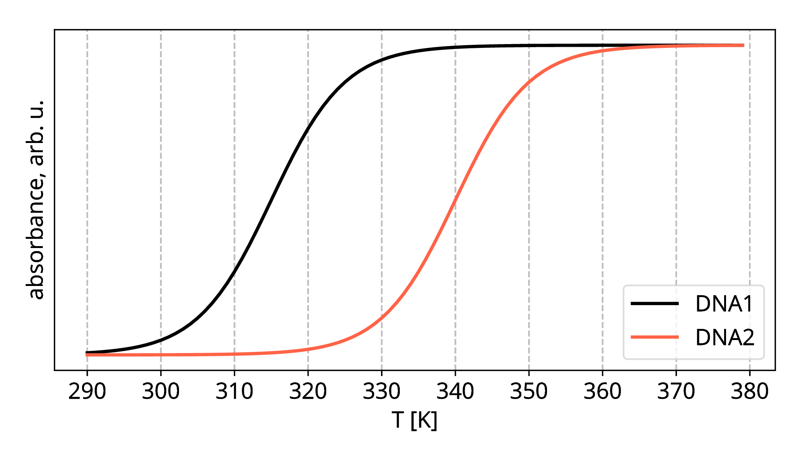

28.4 Considering the plot shown above, decide whether the following statements are true or false or whether that cannot be answered based only on the plot.

1. At 320 K, the concentration of dsDNA1 is lower than the concentration of dsDNA2.

True False Cannot be answered

1. The melting temperature *Tm* of DNA1 is higher than the melting temperature of DNA2.

True False Cannot be answered

1. dsDNA of the species DNA1 is more thermodynamically stable than that of the DNA2 with respect to their single-stranded forms.

True False Cannot be answered

1. dsDNA1 is composed of a larger number of nucleobase pairs than dsDNA2

True False Cannot be answered

The Rous sarcoma virus is a retrovirus. Its genetic information is stored in a single strand of RNA rather than in dsDNA; recall that RNA contains uracil instead of thymine (Figure 1). The virus uses an enzyme, reverse transcriptase, to synthesize its complementary DNA (cDNA) strand, which is then transcribed to messenger RNA (mRNA). Finally, the mRNA is translated to a polypeptide strand in the ribosome of the infected cell.

The following fragment of 8 nucleotides was identified in the RNA of the virus: 5′-CCCCAGGU-3′.

28.5 Write the sequences of cDNA and mRNA corresponding to the octanucleotide. Mind the orientation of the molecule, and identify the 5′- and 3′-termini.

28.6 How many possible single-stranded RNA octanucleotides do exist?